PLANET EARTH & BEYOND – EARTH SYSTEMS
Electronic Science LabBook
Designed by BLU

When you are required to put an answer in this booklet, the point at which you start typing is marked with a red X. Your typed answer should also appear in red. Delete the X leaving just your answer.
If you are required to paste or draw something, this is stated in BLUE. You can then photograph your work and paste it into this LabBook. In many experiments and investigations, you will be asked to photograph or video the experiment. You should insert these in the appropriate place in this LabBook.
When you are asked to look at a website for information to write an answer don’t just cut and paste the information in. Read the information and write an answer in YOUR OWN WORDS. You may wish to discuss your answer with your classmates and teacher first to make sure you understand it correctly.

For additional work (e.g. homework, revision) you will use the following books. You will be told which pages to use.
SciPad Book 1 Pg 221-228
Science World 9 textbook (written as SW9) Pg 187-203

Learning outcomes for this topic
Describe the relationship between the Sun, Earth and Moon and the gravitational force of attraction.
Task 1
Task 2
Describe how the strength of the gravitational force of attraction is linked to the mass of the object
Task 3
Explain differences in weight of an object on the Earth and the Moon
Task 4
Task 5
Task 6
Explain the day cycle
Task 7
Task 8
Task 9
Explain the annual cycle and the cause of the seasons
Task 10
Task 11
Explain the lunar cycle and the phases of the Moon
Task 12
Task 13

Explain the relationship between the positions of the Sun, Earth and Moon to cause different tides
Task 14
Task 15

Describe the relationship between the Sun, Earth and Moon and the gravitational force of attraction.

Task 1

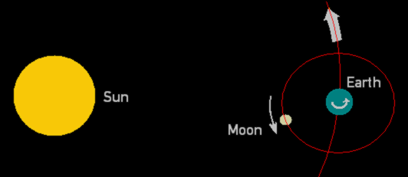

Use the picture above to describe the positions and movement of these three bodies in space as well as the size (Largest, middle, smallest).
Sun
Position in the solar system X
Movement X
Size X

Earth
Position in the solar system X
Movement X
Size X

Moon
Position in the solar system X
Movement X
Size X

Task 2
The Sun-Earth-Moon system is held in place with gravity.
Write your definition of gravity
X

Describe how the strength of the gravitational force of attraction is linked to the mass of the object

Task 3
Fill in the gaps from http://coolcosmos.ipac.caltech.edu/ask/300-What-is-gravity-
X is a X which tries to X two objects X each other. Anything which has X also has a gravitational pull. The more X an object is, the X its gravitational pull is.

Which object in the solar system has the most gravitational pull X
Explain why X

Complete the following
Earth’s gravity is X than the Sun because Earth has X X than the Sun, however Earth’s gravity is X than the Moon’s because Earth has X X than the Moon.

Watch the video for an idea of how gravity works and creates orbits for planets around a star.
https://www.youtube.com/watch?v=MTY1Kje0yLg

Explain differences in weight of an object on the Earth and the Moon

The force of gravity is the force with which the Earth, Moon, or other object with mass attracts another object towards itself. This force is the weight of the object. All objects upon Earth experience a force of gravity that is directed "downward" towards the center of the Earth. The force of gravity is always equal to the weight of the object as found by the equation:

Weight = mass * gravity

Mass is the amount of matter in an object, measured in kilograms (kg).
Weight is a force so is measured in Newtons (N).
The amount of gravity is different due to the mass of the object so objects will have a different weight on Earth or the Moon.

Task 4
Which has more gravity, the Earth or the Moon? X
Explain why X

Task 5
Calculate the weight force of a 50kg person if they were on
Earth (gravity = 10)

Moon (gravity = 1.6)

Task 6
Watch this video https://www.youtube.com/watch?v=efzYblYVUFk
The astronauts and their spacesuits on the Moon have a combined mass of around 170kg but they can jump about as high as you can on Earth.
Explain why X

Explain the day cycle

Earth spins as it orbits the Sun. We can’t feel it moving because we are moving as well.

Task 7
How long does it take to complete one spin? X
The side of the Earth that is pointing towards the Sun is lit up by sunlight. This is X
The opposite side is experiencing no light or X

Use this animation to answer the questions http://www.classzone.com/books/earth_science/terc/content/visualizations/es0404/es0404page01.cfm?chapter_no=visualization
If you were looking down on the North Pole, which way does the Earth spin? X
As we look into the sky, objects like stars, the Sun and the Moon appear to move across the sky. Which direction do these objects appear to move? X

Task 8
Write a short paragraph explaining why the Sun rises in the east, moves across the sky during the day and then sets in the west and it becomes night.
X

Task 9
Do SciPad pg 221-222

Explain the annual cycle and the cause of the seasons

Task 10
Watch the video
https://www.youtube.com/watch?v=Pgq0LThW7QA
Do SciPad pg 223

The seasons are caused by how intense the sunlight is that arrives from the Sun.
Due to the tilt of the Earth, the sunlight gets spread out at different times of the year depending on whether the part of the Earth you are on is tilted towards or away from the Sun.

Task 11
Use this animation to answer the following questions. (Make sure you move the stick figure in the top right box to 37 degrees south as this where NZ is)
http://astro.unl.edu/naap/motion1/animations/seasons_ecliptic.html

The southern hemisphere (and NZ) is tilted towards the Sun during which months? X
This season is X
Describe the angle of the sunlight hitting the ground at this time X
Describe how spread out each of the sunbeams is at this time X
Does this increase or decrease the intensity of the sunlight at this time of the year? X
Does this make the temperature increase or decrease? X

The southern hemisphere (and NZ) is tilted away the Sun during which months? X
This season is X
Describe the angle of the sunlight hitting the ground at this time X
Describe how spread out each of the sunbeams is at this time X
Does this increase or decrease the intensity of the sunlight at this time of the year? X
Does this make the temperature increase or decrease? X

Explain the lunar cycle and the phases of the Moon

As the Earth orbits the Sun, the Moon is also orbiting the Earth.
At different times during the Moon’s orbit, the angle of the sunlight reflecting from it changes.
This makes us see a different amount of the Moon’s surface lit up by the sunlight.
The amount of surface we see is a cycle once per month and the cycle is broken up into different phases.
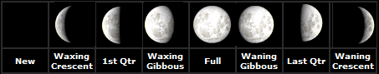

Task 12
Do SciPad pg 224-227

Task 13
Name the four main phases of the Moon X
If it takes the Moon 29.5 days to complete one cycle, how long does it take to get from one main phase to the next? X
What is this period of time the same as? X
Therefore one lunar cycle is approximately X

Explain the relationship between the positions of the Sun, Earth and Moon to cause different tides

The Moon’s gravity pulls on objects on Earth. This includes the oceans, creating a bulge of water being pulled towards the Moon. The Earth spins inside this water bulge so the water is dragged higher up the shore during high tide but not as much during low tide.

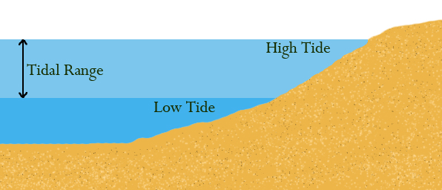

Watch this animation to understand how the water bulge actually looks like
http://oceanservice.noaa.gov/education/kits/tides/media/tide01_480.gif

Task 14
The Sun’s gravity also pulls on the water. When the gravitational pull of the Moon and the Sun combine they will change the height of the tide
Watch this animation
http://www.mmscrusaders.com/newscirocks/tides/images/whytides.gif
Describe the size of the bulge when the Sun, Earth and Moon are in a line X
This is called a X
The high tide is X than usual

Describe the size of the bulge when the Sun, Earth and Moon are at 90^{O} to each other X
This is called a X
The high tide is X than usual

Task 15
Do SciPad pg 228

