MATERIAL WORLD – ATOMS AND RECACTIONS
Electronic Science LabBook

When you are required to put an answer in this booklet, the point at which you start typing is marked with a red X. Your typed answer should also appear in red. Delete the X leaving just your answer.

If you are required to paste or draw something, this is stated in BLUE. You can then photograph your work and paste it into this LabBook. In many experiments and investigations, you will be asked to photograph or video the experiment. You should insert these in the appropriate place in this LabBook.

When you are asked to look at a website for information to write an answer don’t just cut and paste the information in. Read the information and write an answer in YOUR OWN WORDS. You may wish to discuss your answer with your classmates and teacher first to make sure you understand it correctly.

For additional work (e.g. homework, revision) you will use the following books. You will be told which pages to use.
Science World 9 textbook (written as SW9) – chapter, 9, pages 166-186
Scipad

Learning outcomes for this topic
Understand the structure of the atom, and the structure of the periodic table
Understand that atoms are the basic building block of all matter
Task 1
Recall the symbols of common elements
Task 2
Task 3
Task 4
Task 5
Describe the structure of atoms
Task 6
Predict the number of protons, neutrons and electrons from the atomic number and mass number
Task 7
Task 8
Task 9
Distinguish between metals and non-metals using their position on the PT and their properties
Task 10
Task 11
The importance of chemicals and chemical reactions
Distinguish between atoms and molecules
Task 12
Classify substances as elements, compounds and mixtures
Task 13
Task 14
Task 15
Distinguish between elements and compounds
Distinguish between mixtures and compounds
Task 16
Task 17
Be able to interpret a formula
Task 18
Task 19
Distinguish between chemical and physical change
Task 20
Link observations to chemical or physical changes
Task 21
List evidence for a chemical reaction occurring
Task 22
Task 23
Task 24
Task 25
Identify the reactants and products for a chemical reaction
Write simple word and formula equations for common reactions
Task 26
Task 27
Recall the three gas tests
Task 28
Task 29

Understand the structure of the atom, and the structure of the periodic table

Understand that atoms are the basic building blocks of all matter

Task 1
Take pictures of 3 examples of matter around the school in 5 minutes and label them, are they made of atoms? Insert your pictures below.

Recall the symbols of common elements
Periodic Table http://www.ptable.com/
Element song! http://www.privatehand.com/flash/elements.html

Task 2
Learn the names and symbols of the first 20 elements on the periodic table and some of the other common elements – Iron, Copper, Zinc, Silver, Bromine, Iodine, Gold, Mercury, Lead, Platinum, Uranium.

Construct a table with the 31 elements mentioned above with their name and symbol.

Task 3
TRY THIS FIRST 20 ELEMENTS TEST
http://chemistry.about.com/od/testsquizzes/l/blsymbolquiz.htm

Task 4
Try this quizlet link to test and extend your understanding http://quizlet.com/11257964/element-names-flash-cards/
Definition of Element: X
For example: Oxygen, as well as all those on the periodic table.

Task 5
Develop a poster of an element. Choose an element that no one else in your class is researching, find out its uses, picture, discovery, and any other interesting facts ( physical properties) and make an electronic poster/brochure. Then copy and paste it in the area below ( apps like pic collage will do). My chosen element is X

The structure of an atom
Although the word 'atom' comes from the Greek for indivisible, we now know that atoms are not the smallest particles of matter. Atoms are made from smaller subatomic particles.

Task 6
Look at the picture below and complete this table
Sub-atomic particles | Location | Charge | Relative Mass
Proton | X | X | X
Neutron | X | X | X
Electron | X | X | 1/1820

ELECTRONS ARE 1820 TIMES SMALLER than the protons and neutrons so we ignore the mass.

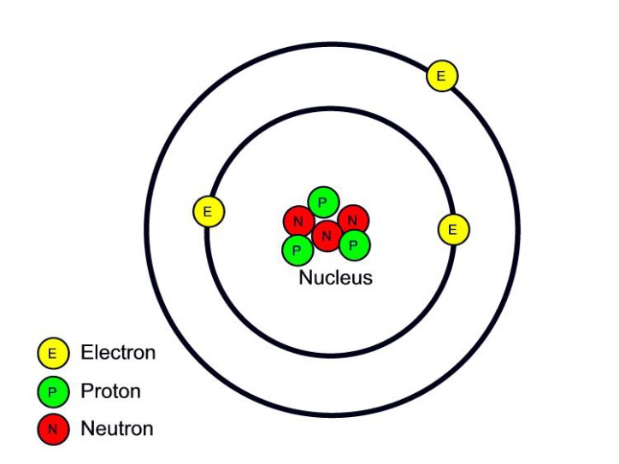

Predict the number of protons, neutrons and electrons from the atomic number and mass number

Task 7
What do these two terms mean?
Atomic Number: X
Mass Number: X

Can you work out the number of Proton, Electrons and Neutron? ( PEN number)
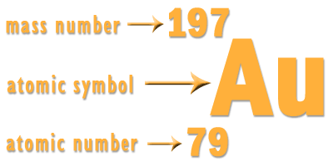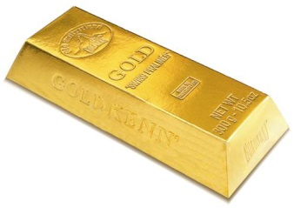

Task 8
How many P,E,N does an atom of gold have?
P X
E X
N X
How do we work out the number of protons, neutrons and electrons? X (Explain clearly)

The type of element is determined by the number of X

Task 9
Complete the missing spaces:
Element name | Atomic number | Mass number | Proton number | Neutron number
 | 2 | 4 |  | 2
 | 7 | 14 | 7
neon | 10 | 20
 |  |  | 3 | 4
 | 20 |  |  | 20
 |  |  | 12 | 12

Distinguish between metals and non-metals using their position on the PT and their properties

The columns on the periodic table are called X
Group 1 all have 1 outer shell electron and are not stable, they want to lose 1 electron to have a full shell

The rows on the periodic table are called X
Elements on the same period have the number of electron shells

Properties of metal and non-metals
Look at the website
http://www.s-cool.co.uk/gcse/chemistry/metals-the-reactivity-series/revise-it/properties-of-metals-and-non-metals
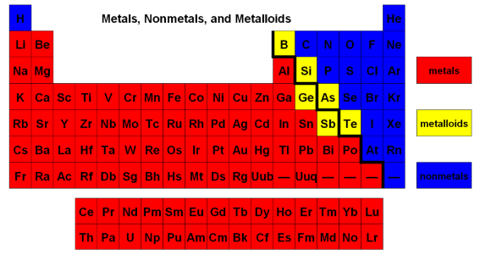

Where are the metals found on the periodic table? X
Where are the non-metals found on the periodic table? X
Where are the metalloids found on the periodic table? X

Task 10
Give 3 example of metals and non-metals each, then provide the uses of each element you have given.
Metal names
Picture
Use

Non-Metal names
Picture
Use

Task 11
Why do we use Iron for making cooking pans? X
Why do carbon and hydrogen compounds were used to make plastic handles for cooking pans? X
Why do we use copper for electrical wires? X

The importance of chemicals and chemical reactions

Distinguish between atoms and molecules

Definition of Atom: X
Definition of Molecule: X
How is an atom different to a molecule? X

Task 12
Give 2 examples on molecules: X Explain why they are molecules. X
And 2 examples of things made of just atoms: X

Classify substances as elements, compounds and mixtures

An element cannot be broken down into simpler substances. Water can be broken down in to oxygen and hydrogen gases. So water is not an element.

Task 13
Read SW pg 168-169, Homework pg 169 activity
Most of the elements are metals. E.g. X
The rest are non-metals. E.g. X
Metalloids are between metal and non-metal. E.g X

Definition of a Compound: X
Definition of a Mixture: X

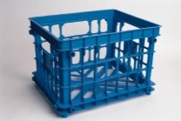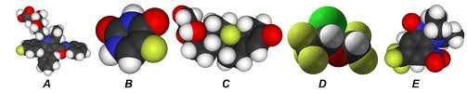
Is plastic an element, mixture or compound? X
How about A-E in the above picture? X

Task 14
Take pictures of 3 objects to show an example of an element, a mixture and a compound and list what they are made of.
An example on water is done for you
Object name | Picture | Compound | element | What is it made of ?
water | 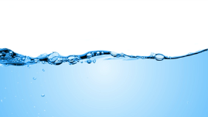

Molecules are made of non-metals chemically bonded e.g. oxygen molecule, water molecule.
Which of these molecules is a compound? X
Which molecule is an element? X

Task 15
SW pg 171-172 exercises for homework

Distinguish between elements and compounds

Distinguish between mixtures and compounds

You may find these websites helpful to preview to complete the task below
http://www.bbc.co.uk/bitesize/ks3/science/chemical_material_behaviour/compounds_mixtures/revision/3/

http://www.bbc.co.uk/bitesize/ks3/science/chemical_material_behaviour/compounds_mixtures/revision/1/

Task 16
Try this Quiz online to ensure your understanding
http://quizlet.com/11278379/jc-science-chemistry-element-compound-mixture-check-list-chap-19-flash-cards/

Task 17
Go to this website and complete the worksheet
http://chemsite.lsrhs.net/Intro/handouts/Elements_compounds_mixtures.pdf

Interpret chemical formulae:
A chemical formulae tells you what elements are in the chemical, also the ratio of each element in the chemical.

For example the formula for carbon monoxide is CO. It tells you that each molecule of carbon monoxide consists of one carbon atom joined to one oxygen atom.

Take care when writing your symbols and formulae. Be careful about when to use capital letters. For example CO means a molecule of carbon monoxide but Co is the symbol for cobalt.

Formula and formulae
The word 'formulae' ("form-u-lee") is the plural of 'formula'. If we have more than one formula, we don't say formulas, we say formulae.

Numbers in formulae
If the molecule contains more than one atom of an element we use numbers to show this. The numbers are written to the right and slightly below the element symbol. For example, the formula for carbon dioxide is CO₂ . It tells you that each molecule has one carbon atom and two oxygen atoms.

Take care when writing these formulae. The small number is written at the bottom right corner. For example CO₂ is correct but CO² is wrong.

Some formulae are more complicated. For example, the formula for sodium sulphate is Na₂SO₄ . It tells you that sodium sulphate contains two sodium atoms (Na₂ ), one sulphur atom (S) and four oxygen atoms (O₄ ).

Task 18
Try these exercises:
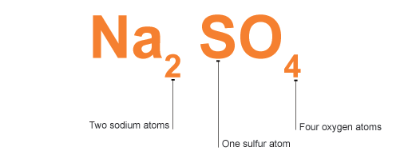
A molecule of sulphur dioxide (SO₂) contains……….one sulphur atom and two oxygen atoms
A compound of sodium sulphide (Na₂S) contains……… X
A compound of iron oxide (Fe₂O₃) contains……… two iron atoms and three oxygen atoms
A compound of potassium hydroxide (KOH) contains………. X
A molecule of nitric acid (HNO₃) contains…….. X
A compound of silver nitrate (AgNO₃) contains……… X
A molecule of sulphuric acid (H₂SO₄) contains……… X
A compound of barium hydroxide (Ba(OH)₂) contains……… X
A molecule of glucose (C₆H₁₂O₆) contains………. X
A molecule of ethanol (C₂H₅OH) contains………. X
Why do you think the chemical formula for ethanol is C₂H₅OH and not C₂H₆O? X

Sometimes we see brackets followed by a subscript in a formula, this means you times everything inside the bracket by the subscript
For example, the ₂ in (NH₄)₂CO₃ means there are 2× 1 = 2 N atoms and 2× 4 = 8 H atoms.

Task 19
Complete the rest of this table:
Compound | Formula | Elements present
Hydrogen peroxide | H₂O₂ | 2 H atoms and 2 O atoms
Aluminium Hydroxide | Al(OH)₃ | X
Copper sulfate | CuSO₄ | X
X | FeS | X
Lead Nitrate | Pb(NO₃)₂ | X
Ammonium carbonate | (NH₄)₂CO₃ | X

Need help? You can Read through this website below.
http://www.bbc.co.uk/schools/gcsebitesize/science/ocr_gateway/chemical_concepts/fundamentalrev3.shtml

Distinguish between chemical and physical change
http://www.bbc.co.uk/bitesize/standard/chemistry/elementsandreactions/chemical_reactions/revision/1/
PHYSICAL REACTION
What is a physical reaction: X
CHEMICAL REACTION
What is a chemical reaction: X

Task 20
Give 3 examples of physical reactions:
X
X
X
Give 3 examples of chemical reactions:
X
X
X

Link observations to chemical or physical changes

http://www.bbc.co.uk/bitesize/standard/chemistry/elementsandreactions/chemical_reactions/revision/1/

Task 21
What are the signs that show a chemical change has occurred, list 6 of them (be careful as some signs can occur in physical changes too). X

Which sign also occur in both chemical and physical changes: X

List evidence for a chemical reaction occurring

Task 22
Try the quiz below
http://quizlet.com/26629337/physical-changes-chemical-changes-pracitice-flash-cards/

Task 23
Is this a chemical or physical change? Explain X
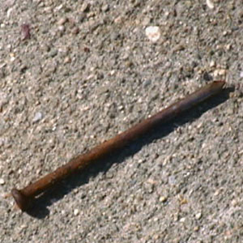

Task 24
Test your knowledge so far: go to the following site to try out some quizzes
http://www.softschools.com/matching_games/science/5th_grade_matter/1076/

Task 25
Try this online Quiz http://www.edinformatics.com/math_science/a_p_chem.htm

Identify the reactants and products for a chemical reaction

Reactants and Products
The chemicals we have at the start of a reaction are called reactants. When a chemical reaction takes place the atoms in these substances are rearranged to form new chemicals. The substances formed in a reaction are called products.
Example
If copper oxide is heated with magnesium it will react to form magnesium oxide and copper. We can write this as a simple word equation:

copper oxide | + magnesium |  | magnesium oxide | + copper

Reactants  (substances we started the reaction with), always go on the left. |  | Products  (substances formed during a reaction), always go to the right of the arrow.

Write simple word and formula equations for common reactions

Task 26
For each of the chemical reactions below:
Highlight or circle the reactants in one colour and the products in another colour, (colour in the boxes in the key, so you can remember which is which!)
Reactants = colour products = colour

Task 27
Complete the word equation for each reaction, reaction one is done for you:

Reaction One
Sam mixed together some eggs, milk and flour. When he heated them in a large pan they reacted to form a big pancake!
eggs + milk + flour pancake

Reaction Two
When Katerina dropped a lump of magnesium into a test tube of hydrochloric acid, the chemical magnesium chloride was formed. Katerina also noticed a gas being formed. When a lit splint was placed in the gas it made a squeaky ‘pop’ sound.

…………………….........  ……………………......... | + Magnesium |  | Magnesium  chloride | + ……………….........
Reaction Three
Luke reacted a lump of calcium carbonate with some sulphuric acid. Two of the products formed were water and calcium sulphate. The other product formed was a gas that turned lime water milky.

………………........  ………………........ | + Calcium  carbonate |  | ………………........ | + ………………....  ………………........ | ………………........  dioxide
Reaction Four
Bradley heated some copper turnings with some sulphur powder very strongly in a test tube. He noticed that at the end of the experiment, there was a bluish colour left on the surface of the copper.

………………........  ………………........ | + Sulphur |  | ………………........  sulphide

Reaction Five
Chelsea was given some nitric acid and some iron oxide. She reacts these together and finds that she makes a solution of iron nitrate and iron water.

……………………………..  ……………………………. | + iron  …………………………. |  | ……………………………  …………………………… | + …………………………

Reaction Six
Milos put a brand new iron nail outside and studied it for several weeks. He noticed that gradually the surface of the nail became coated with rust. He read in a science book that the chemical name for rust is “iron oxide”.

………………........ | + …………………… |  | ………………........  ……………………..

Reaction Seven
Shona was learning about photosynthesis. She looked on the internet and found that in this process, plants take in carbon dioxide gas from the air and water from the ground. Using energy from the sun they can turn these chemicals into a kind of sugar called glucose and the gas oxygen.
LIGHT
……………………………..  ……………………………. | +………………………… |  | +…………………………… | + …..………………………

Reaction Eight
Jourdan told Shona that plants and animals respire. In this reaction they use up glucose and oxygen and make carbon dioxide and water and release energy that they can use to stay alive.
……………………… | + ……………………. |  | +………………........  ……………………….. | +..……………….... | + ENERGY

Recall the three gas tests

Task 28
Three important gases:
Fill in a summary for these important gases
Gases | properties | uses | Equation of making the gas
H₂
O₂
CO₂

Gas tests

Task 29
Watch this video http://www.youtube.com/watch?v=LiAvDpl5aJA summarise what you saw
Gases | Test ( with a picture) | Observation for positive test
H₂
O₂
CO₂

If you have finished and would like some extension work, try these:
http://quizlet.com/8927231/non-metals-flash-cards/
http://www.softschools.com/quizzes/science/physical_chemical_changes/quiz382.html
http://chemistry.about.com/od/testsquizzes/l/blatomsperiodicquiz.htm
http://www.sciencegeek.net/Chemistry/taters/Unit1AtomicStructure.htm
http://www.tutorvista.com/content/science/science-i/structure-atom/multiple-choice.php
http://quizlet.com/14011471/chemical-and-physical-changes-flash-cards/
http://quizlet.com/14378861/atoms-flash-cards/

