NATURE OF SCIENCE – BEING SCIENTIFIC
Electronic Science LabBook
Designed by BLU

When you are required to put an answer in this booklet, the point at which you start typing is marked with a red X. Your typed answer should also appear in red. Delete the X leaving just your answer.
If you are required to paste or draw something, this is stated in BLUE. You can then photograph your work and paste it into this LabBook. In many experiments and investigations, you will be asked to photograph or video the experiment. You should insert these in the appropriate place in this LabBook.
When you are asked to look at a website for information to write an answer don’t just cut and paste the information in. Read the information and write an answer in YOUR OWN WORDS. You may wish to discuss your answer with your classmates and teacher first to make sure you understand it correctly.

For additional work (e.g. homework, revision) you will use the following books. You will be told which pages to use.
- SciPad – pages xx-xx
- Science World 9 textbook (written as SW9) – pages 1-35

Learning outcomes for this topic
Safety in the Laboratory
- Describe and explain safety procedures and practices in the laboratory
- Identify the safety/ warning signs in laboratories.
- Be able to take precautions to ensure personal safety in the laboratory
- Recognise and avoid dangerous situations in the laboratory

Laboratory Equipment
- Be able to identify and correctly use laboratory equipment
- Draw scientific diagrams for laboratory gear and experimental setups

Measurement
- Read and record volume, mass, distance, temperature and time from basic science equipment.
- Take accurate observations and measurements

Experiments
- Design simple ‘fair test’ experiments using the Scientific Method
- Distinguish between observation, hypothesis and inference
- Become skilled at recording information in tables
- Decide when to use bar graphs and when to use line graphs; and when to do a 'line of best fit'
- Become skilled at drawing, labelling and interpreting graphs correctly
- Interpret results from experiments and apply to other situations
- Write experimental reports
- Follow instructions and perform simple experiments

Importance of Science
- Understand the importance of Science to everyday life
- Be able to apply scientific thought processes to data from everyday life

Safety in the Laboratory

Describe and explain safety procedures and practices in the laboratory

Identify the safety / warning signs in laboratories.

Reference: SW9 Pg 6-8

Watch this video: http://www.youtube.com/watch?v=tsAHt0FiwNM
List all of the safety rules.
X

Watch the ClickView video called “Playing It Safe in the Lab”.

Complete SciPad page 7

There are many safety and warning signs in the laboratory on chemicals and equipment.
Use this website to copy and paste the signs into your eLabBook.

http://www.hse.gov.uk/chemical-classification/labelling-packaging/hazard-symbols-hazard-pictograms.htm

Harmful:
X
Highly or extremely flammable explosive:
X
Dangerous for the environment:
X
Oxidising:
X
Corrosive:
X
(Very) toxic:
X
Irritant:
X

Complete SciPad page 8

Be able to take precautions to ensure personal safety in the laboratory

Recognise and avoid dangerous situations in the laboratory

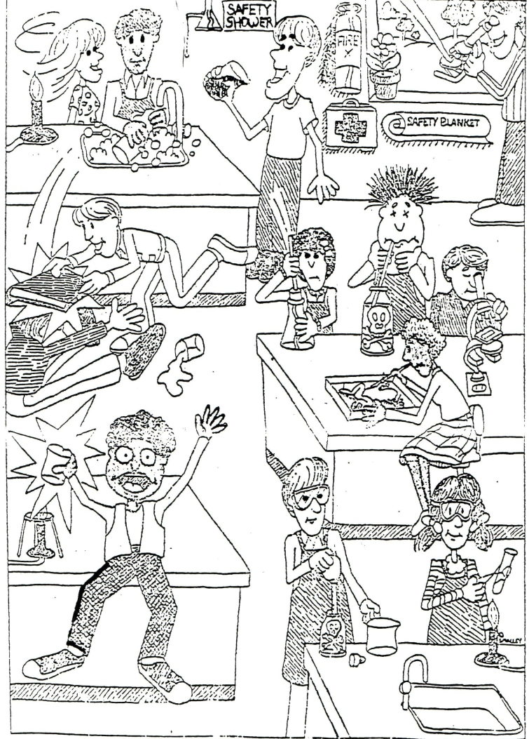
In the picture above, identify THREE things that are unsafe in the laboratory and THREE things that students are doing correctly.
Unsafe:
X
X
X

Correct:
X
X
X

Laboratory Equipment

Be able to identify and correctly use laboratory equipment

Reference SW9 Page 2-5

There are many pieces of equipment used in the laboratory. They are used for holding, containing, measuring and heating.

List the equipment used for HOLDING liquids, solids and hot items
X

List the equipment used for CONTAINING liquids, solids and hot items
X

List the equipment used to MEASURE liquids
X

List the equipment used for HEATING things
X

Complete SciPad page 9 and 10

Watch the ClickView video called “Checking Out Your Lab”.

Draw scientific diagrams for laboratory gear and experimental setups

All of the equipment can be drawn scientifically. These must be drawn from side-on (two-dimensionally).
Complete SciPad page 10 and 11

The Bunsen Burner
Bunsen Burners are used to heat up substances in the laboratory.
List the steps used for lighting a Bunsen Burner – you may also want to video or take photos of each step.
X

Complete SciPad page 12

When heating a liquid it is important to be safe.
Explain why a boiling tube used to heat liquids not a test tube.
X

Explain why a test tube holder is used to heat liquids not tongs.
X

Complete SciPad page 14 and 15

Measurement

Read and record volume, mass, distance, temperature and time from basic science equipment.

Take accurate observations and measurements

Reference SW9 Page 24-26

Accurate measurements are very important in science.
Each piece of measuring equipment has a scale to tell you the amount accurately.
Describe how to read the scale from a piece of measuring equipment
X

Complete SciPad page 17 and18

When finding out how much matter is in a substance (solid, liquid or gas) takes up, we measure its X
What piece of equipment is used? X

When finding out how much space a substance (solid, liquid or gas) takes up, we measure its X
What piece of equipment is used? X

Measuring Cylinders
List the different sizes measuring cylinder.
X
Explain why measuring cylinders come in different sizes.
X
Which size of measuring cylinder would you use if you want to measure:
23mL - X
142mL - X
7.3mL - X
What is the curved level of the liquid called? X
Where do we take the measurement from? X

Complete SciPad page 19

Experiments

Design simple ‘fair test’ experiments using the Scientific Method

Distinguish between observation, hypothesis and inference

Reference: SW9 page 17-23

The steps in the Scientific Method are:
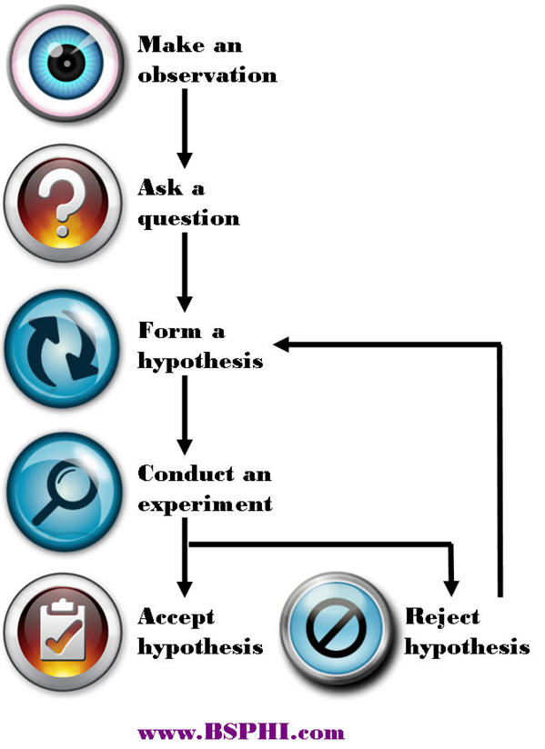
Use this site for help
http://www.sciencebuddies.org/science-fair-projects/project_scientific_method.shtml#overviewofthescientificmethod

Define the following terms:
Observation: X
Hypothesis: X

Watch this video of Edward Jenner, the English doctor who discovered vaccination.
http://www.youtube.com/watch?v=jJwGNPRmyTI

Describe how Jenner showed he was using the scientific method through observing.
X

Define the term inference. X

What did Jenner infer about cowpox and smallpox? X

Become skilled at recording information in tables

Data tables should follow the same format:
- The variable you changed in the experiment is in the left column.
- The results for all of the different trials for the variable you measured are the middle columns.
- The average of all the trials in the right column.

Explain why the measurement needs to have at least THREE trials. X

Explain why an average for the measurement is used. X

Use this data to produce a table. It is data of how far it takes a toy car to stop after it rolls down a ramp of different heights.

Ramp height (cm) 10, Distance travelled (cm) 19, 17, 23
Ramp height (cm) 15, Distance travelled (cm) 33, 29, 30
Ramp height (cm) 20, Distance travelled (cm) 41, 43, 41
Ramp height (cm) 25, Distance travelled (cm) 52, 56, 53
Ramp height (cm) 30, Distance travelled (cm) 61, 59, 65

Decide when to use bar graphs and when to use line graphs; and when to do a 'line of best fit'

Become skilled at drawing, labelling and interpreting graphs correctly

The type of graph you use depends on the type of data you have.
Discrete is either/or data e.g. type of animal, favourite colour, number of legs.
Continuous is a measurement e.g. height, weight, length, temperature, time.

Bar graphs are used when you have discrete data
Histograms are used when the data is continuous but each measurement falls into a range of measurements e.g. height between 150-155cm.
Line graphs are used when the data is continuous.

The line graph is the most commonly used type of graph.

To correctly draw a graph you must use TELLX. TELLX stands for -
T: X
E: X
L: X
L: X
X: X

Using the data table you produced before, draw graphs on graph paper. Make sure to use TELLX.

Complete SciPad page 20-21

Interpret results from experiments and apply to other situations

Using the data and graph you have previously completed, answer the following questions:

What is the general trend with the toy car stopping distance compared to the ramp height?
X

Based on this data, if you were to design a playground slide, how would you make sure the people using it wouldn’t go too far at the end?
X

Explain how you got this solution.
X

Write experimental reports

Follow instructions and perform simple experiments

Reference SW9 page 30-31

Complete the simple investigation on SciPad page 22.

Remember safety is important!

Importance of Science

Understand the importance of Science to everyday life

Be able to apply scientific thought processes to data from everyday life

Watch the ClickView video called “What’s So Special About Science”.

