**PHYSICAL WORLD – ELECTRICITY**

**Electronic Science LabBook**

***Designed by FRY***

When you are required to put an answer in this booklet, the point at which you start typing is marked with a **red X.** Your typed answer should also appear in **red**. Delete the **X** leaving just your answer.

If you are required to paste or draw something, this is stated in **BLUE.** You can then photograph your work and paste it into this LabBook. In many experiments and investigations, you will be asked to photograph or video the experiment. You should insert these in the appropriate place in this LabBook.

When you are asked to look at a website for information to write an answer don’t just cut and paste the information in. Read the information and write an answer in **YOUR OWN WORDS**. You may wish to discuss your answer with your classmates and teacher first to make sure you understand it correctly.

For additional work (e.g. homework, revision) you will use the following books. You will be told which pages to use.

SciPad Book 2 Pg 124-148

Science World 10 textbook (written as SW10) Chapter 13

**Learning outcomes for this topic**

**Learning outcomes for this topic**

Describe current electricity

Task 1

Task 2

Explain the difference between conductors and insulators

Task 3

Task 4

Describe the function of components in a circuit

Task 5

Describe and predict how current will flow through a circuit

Task 6

Draw simple series and parallel electrical circuits

Task 7

Describe and measure current and voltage in different circuits

Explain differences in electrical measurements in different circuits using correct terminology.

Task 8

Task 9

Task 10

Task 11

Task 12

Task 13

Task 14

Task 15

Task 16

Task 17

Calculate power of components in a circuit

Task 18

## Describe current electricity

### Task 1

View these websites. Make a brief summary of what you viewed. Share what you have learnt with your group.

<https://archive.org/details/principles_of_electricity>

<http://www.youtube.com/watch?v=x2EuYqj_0Uk>

<http://www.youtube.com/watch?v=EJeAuQ7pkpc>

### Task 2

Select TWO of the follow forms of electricity generation. Share information with the rest of the class.

Useful websites:

[www.gcse.com/energy.htm](http://www.gcse.com/energy.htm) (Non-renewable and renewable tabs)

[www.bbc.co.uk/schools/gcsebitesize/science/aqa/energy/](http://www.bbc.co.uk/schools/gcsebitesize/science/aqa/energy/) (Generating electricity - revise)

<http://www.tes.co.uk/teaching-resource/HOW-ELECTRICITY-IS-MADE-AND-TRANSMITTED-6112912/>

Include:

Information (e.g. how does it work, where can you build them etc)

Advantages

Disadvantages

Methods to choose from:

Wind

Wave

Tidal

Hydroelectric

Geothermal

Solar Panels

Coal

Oil

Gas

Nuclear

## Explain the difference between conductors and insulators

**Electrical Conduction in Metals**

A solid piece of metal, at room temperature, consists of metal *ions* arranged in a regular pattern called a *crystal lattice* with free electrons moving in the spaces between the ions. The motion of the free electrons is random. The diagram represents a piece of metal which does *not* have current flowing through it.

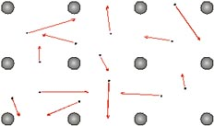

The arrows represent the random motion of the electrons.

If the piece of metal is part of a circuit through which a current is flowing, then another motion is added to the random motion. This motion is more regular and results in a general movement of electrons through the metal.

The size of this movement depends on the current, the type of metal and the dimensions of the piece of metal.

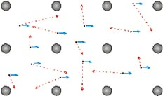

The *resistance* of a piece of metal is due to collisions between the free electrons and the metal ions. The ions "get in the way" of the electrons and slow down their progress through the metal.

Resistance to the flow of current causes the temperature to increase. This resistance causes **electrical energy** to be converted into heat.

### Task 3

Your teacher will provide you with a selection of objects (metals and non-metals). Construct a basic circuit which includes a light bulb. Replace one of the connectors with each of the objects and record your observations in a table.

X

### Task 4

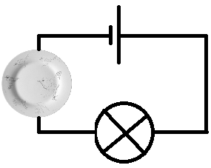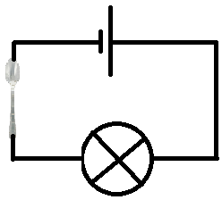

Circuit A has a porcelain plate to complete the circuit.

Circuit B has a metal spoon in to complete the circuit.

Which circuit will complete to allow the bulb to light up? X

Give explanation to your answer.

X

## Describe the function of components in a circuit

### Task 5

In circuit diagrams components are represented by the following symbols. Your teacher will provide you with a collection of components.

|  |  |  |
| --- | --- | --- |
| SYMBOL | NAME | INSERT A PICTURE OF THE COMPONENT FOUND IN THE LAB |
|  | **Bulb** |  |
|  | **Voltmeter** |  |
|  | **Ammeter** |  |
|  | **Resistor** |  |
|  | **Variable resistor** |  |
|  | **Cell** |  |
|  | **Battery** |  |
|  | **Open switch** |  |
|  | **Closed switch** |  |
|  | **Fuse** |  |

## Describe and predict how current will flow through a circuit

An electric current is a **flow of charged particles**.

(The charge is already in the wires (carried by billions of tiny particles called ELECTRONS)

A current in a metal is due to the movement of **electrons**. In a conducting solution (electrolyte), the current is due to the movement of **ions**.

Current is measured using an **ammeter**.

An ammeter measures the **rate of flow of charge**. For simplicity, an ammeter can be thought of as a "counter of electrons": it gives a reading which is proportional to the number of electrons which pass through it per second.

The unit of current is the **Ampere, A**.

An ammeter is always connected in **series** with other components.

### Task 6

For each model of an electrical circuit, identify the part that represents: a) Battery, b) Wires, c) Current, d) Component (e.g. a bulb), e) Electrons



X

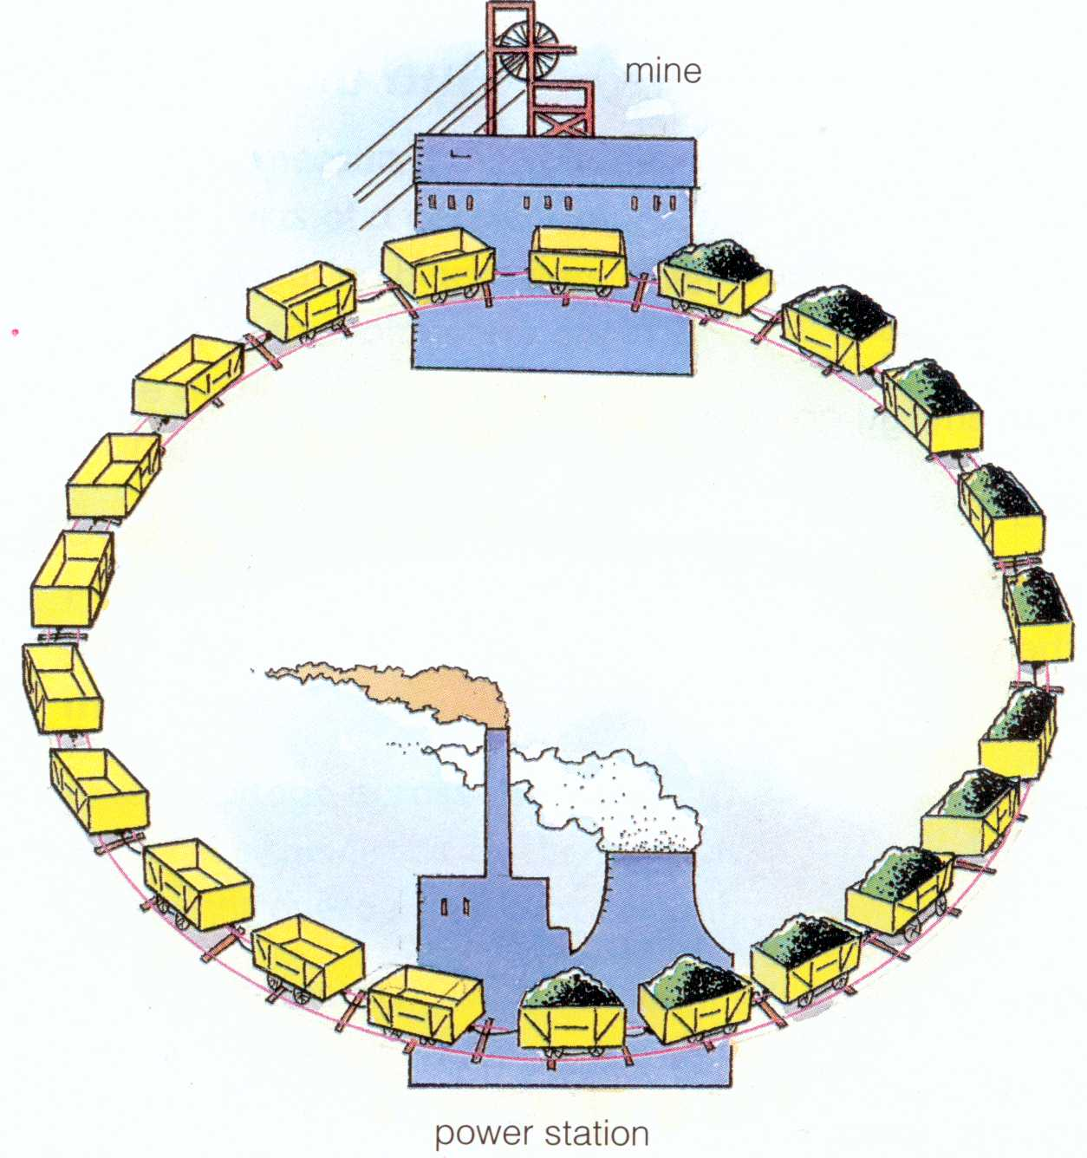

X

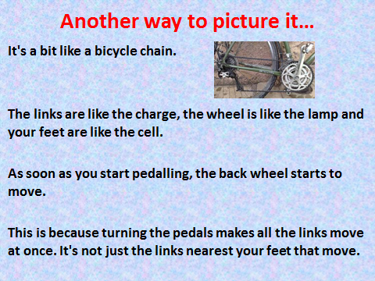

## Draw simple series and parallel electrical circuits

**Series Circuit**

In a series circuit all the components are connected to form a simple loop. In a series circuit the components are connected end to end. The current is the same all the way around the circuit.

### Task 7

Look at each of the following websites on circuit building; voltage and current:

<http://phet.colorado.edu/en/simulation/circuit-construction-kit-dc>

<http://phet.colorado.edu/en/simulation/ohms-law>

<http://phet.colorado.edu/en/simulation/circuit-construction-kit-dc-virtual-lab>

<http://phet.colorado.edu/en/simulation/battery-resistor-circuit>

<http://www.cleo.net.uk/consultants_resources/science/circuitWorld/circuitworld.html>

In a parallel circuit the components are connected side by side and not end to end. The current now has 2 paths it can flow along. The current divides, so that some flows through one lamp and some through the other. When we made a circuit with 2 bulbs connect in parallel both bulbs shine

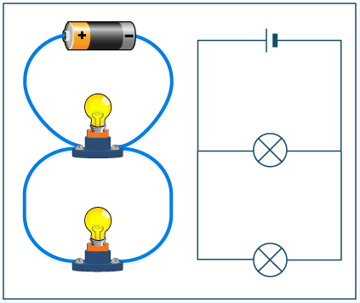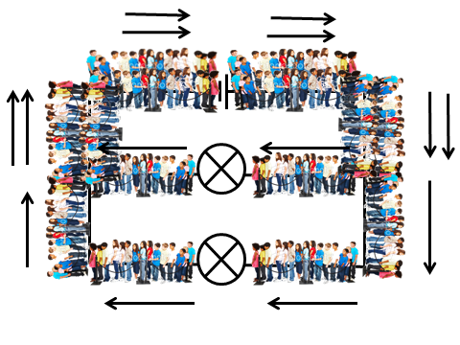

## Describe and measure current and voltage in different circuits

## Explain differences in electrical measurements in different circuits using correct terminology.

**CURRENT**

### Task 8

Highlight all mistakes in the following text, and then write out the correct versions.

Current is the amount of electricity flowing around a circuit. We measure current using an Amp. Current is measured in Volts. The current is the same anywhere in a circuit, so it does not matter where an ammeter goes in a circuit. Current is used up as it goes around the circuit.

### Task 9

THE UNIT FOR CURRENT IS X

ITS SYMBOL IS X

AND IT IS MEASURED IN X

When we made a circuit with 2 bulbs connected in SERIES the current.

When there was one bulb connected the current was X amps

When there were 2 bulbs connected the current was X amps

### Task 10

In this lesson you will investigate the current and voltage in parallel circuits to understand the advantages they have. First, your teacher will measure the current at various points in a series circuit.



A1 = X Amps

A2 = X Amps

A3 = X Amps

A4 = X Amps

What have you found out about the current in a parallel circuit?

**VOLTAGE**

We measured the voltage in the circuit using a X. When we INCREASED the voltage, we are X the amount of ‘push’ of electric current. To measure voltage we must connect the voltmeter in X across the cell.

### Task 11

Voltage is the measure of X X. It tells us how much ‘push’ is left in a circuit at any point. To measure this, we find the difference in push between two parts of a circuit using a X Because the voltmeter compares the ‘push’ in two different places, it must be placed ***in parallel*** across the circuit – it does not form part of the circuit itself.



Next, you will need to measure the voltage in different places in the circuit. To do this, you need to place the voltmeter in the circuit at each of the places shown on this diagram (once before the bulb, once after). Record the readings on your voltmeter.

### Task 12

THE UNIT FOR VOLTAGE / POTENTIAL DIFFERENCE IS X

ITS SYMBOL IS X

AND IT IS MEASURED IN X

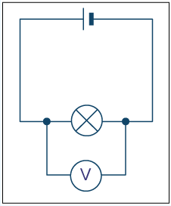

### Task 13



V1 = X Volts

V2 = X Volts

V3 = X Volts

What have you found out about the voltage in a series circuit?

X

### Task 14

**Interpret the following diagram.**

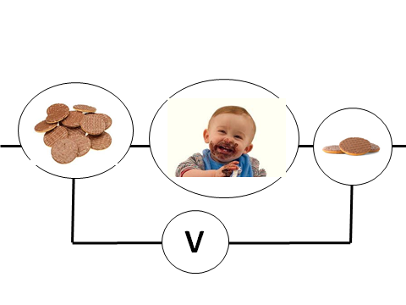

X

### Task 15

Below are some circuit diagrams. Your task is to work out the missing voltages.

**Series Circuits**

**6V**

**6V**

**6V**

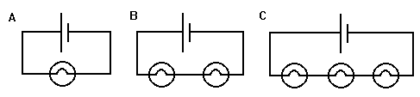

**?**

**?**

**?**

**3V**

**?**

**?**

A = X

B = X

C = X

For Circuit D the voltage of the battery is 6V and for Circuit E the voltage of the battery is 18V.

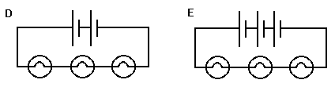

**4V**

D = X

E= X

### Task 16

In this task you will investigate the current and voltage in parallel circuits to understand the advantages they have. To do this you will need to set up a parallel circuit. Start by constructing this circuit:

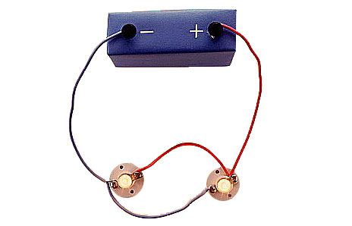

Next, you will need to measure the voltage in different places in the circuit. To do this, you need to place the voltmeter in the circuit at each of the places shown on this diagram (once before the bulb, once after). Record the readings on your voltmeter.



V1 = X Volts

V2 = X Volts

V3 = X Volts

What have you found out about the voltage in a parallel circuit?

X

### Task 17

Insert the missing voltmeter readings.

**12V**

**6V**

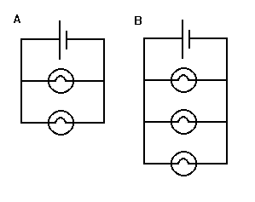

A = X

B = X

## Calculate power of components in a circuit

Any component which possesses resistance will convert electrical energy into heat energy.

Consider the simple circuit shown below.

The current, I, is a measure of the number of Coulombs of charge which pass through the resistor per second.

The voltage, V, is a measure of the number of Joules of energy lost by each Coulomb of charge passing through the resistor.

Therefore, the number of Joules of energy converted to heat by the resistor per second is given by energy per second = voltage × current

We know that Power is a measure of how quickly energy is consumed / used up.

So, P = VI

Power = rate of doing work.

Unit of power = Watt (W) = Joules per second (Js-1)

EXAMPLE:

A toaster has the following information written on it:

2000W ; 240V

Power – the toaster uses 2000J of electrical energy every second.

Voltage

What does this mean?

If you use your toaster for 1 minute (60 seconds ) then the amount of electrical energy used is equal to 2000 x 60 = 120 000J.

The toaster uses 2000J of energy every second. So, in 60 seconds it would use X

Note: BRIGHTNESS = POWER

### Task 18

Construct a circuit consisting of two light bulbs connected in parallel. Record the current and voltage readings for each of them. Use these readings to calculate the power of each light bulb. What do you expect?

|  |  |  |  |
| --- | --- | --- | --- |
|  | Voltage (V) | Current (I) | Power (P) |
| Light bulb 1 |  |  |  |
| Light bulb 2 |  |  |  |

Remove one of the light bulbs and use your voltage and current readings to verify that the brightness remained unchanged. Explain why.

X