Energy and Power
KINETIC ENERGY:
Definition: Energy due to motion is called kinetic energy.
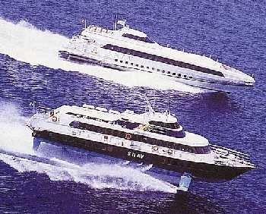
For example, the moving air particles in the wind contain kinetic energy. A wind turbine converts this kinetic energy into mechanical work, which is used to drive an electric generator.
NOTE: This example illustrates that the work done = kinetic energy gained by the body.

POTENTIAL ENERGY
Definition: Energy due to position or mechanical condition is called potential energy
Potential energy is the energy a body has because of its condition or position, e.g. a compressed spring or a rock at the top of a cliff. In the latter case, the rock has energy due to the gravitational force between it and the earth. This, then, is an example of gravitational potential energy.
(Gravitational) Potential Energy
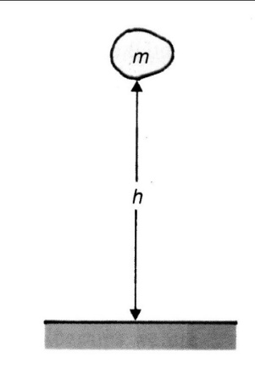
If an object of mass m is lifted from ground level to a height h above the ground, then the potential energy it has gained is equal to the work done in lifting it to this height. This work is
W = Fh
The force F on the body is its weight, which is equal to mg. Therefore, the work done is
W = mgh
Since this is the work done, it is also the energy that the body had before it fell, therefore
EP = mgh
where
· EP = Energy (in Joules)
· m = mass (in kilograms)
· g = gravitational acceleration of the earth (9.8 m/sec2)
· h = height above earth's surface (in metres)
[This is the equation for gravitational potential energy based on the assumption that the potential energy at ground level is zero.]
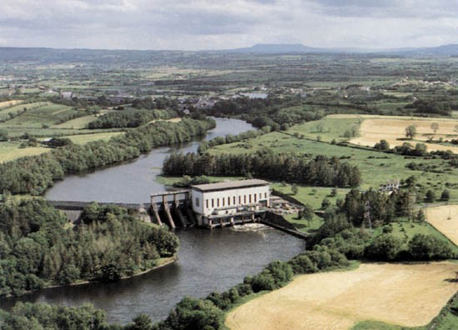
Hydroelectric power station: potential energy of the water is converted to electrical energy in the generators
The water stored behind a dam has potential energy due to its height above the downstream river. As the water is released at the base of the dam it is being converted from potential energy to kinetic energy. The water flows through a turbine which converts the kinetic energy into mechanical work used to drive an electric generator.
Worked example :
A ball of mass 1 kg is thrown up to a height of 12 metres.
Calculate the increase in its potential energy.
Solution:
EP = mgh
EP = (1)(9.8)(12)
EP = 117.6 J
Worked example :
How far above the surface of the earth would the same ball (1 kg) have to be thrown for its potential energy to increase to 1 MJ?
Solution:
EP = mgh
1 × 106 = (1)(9.8) h
h = 1 × 106 ¸ 9.8
h = 102 040.82 m

Energy and Power - Revision Summary
Power is defined as the rate at which work is done.
Power = Work done x time
It can also be defined as the rate at which energy is converted from one form into another.
Power is a scalar quantity and its unit is the watt (W).
From the definition it follows that one watt is equivalent to one joule per second;
1 W = 1 J s^{–1}
Power = Force × velocity
Energy = Power × Time
The efficiency of a device, machine or engine is defined as the ratio of power output to power input.
Efficiency (%) = power output / power input x 100

Calculation Exercises:
Question 01: State what is meant by (i) energy, (ii) power. Give the unit in which each is measured.
Question 02: When a car of mass 1000 kg is accelerated from rest to a speed of 20 m s–1 in 8 seconds, what is the average power developed by the engine?
Question 03: A 30 kW motor in a crane lifts a block of 1000 kg through a height of 10 m in 5 seconds. Calculate the efficiency of the motor if it is working at full power. (g = 9.8 m s–2)
Question 04: A 0.4 kW lift hoist on a building site is used to raise concrete blocks to a height of 6.0 m. If the elevator raises 10 blocks per minute and the weight of each block is 200 N, calculate, ignoring friction, the average power output of the elevator. Also, calculate the efficiency of the lift.
Question 05: Calculate (a) the energy used, and (b) the average power developed, by a man whose mass is 70 kg and who runs upstairs from the ground floor to the first floor of a building in 8 seconds, if there is a vertical height of 3 m between the floors. (Take g = 9.8 m s-2)
Question 06: A motor of efficiency 85% is used to haul a lift up its shaft in 16 seconds. If the total length of the shaft is 100 m and the mass of the lift is 1400 kg, what will the electrical power supplied to the motor be? (Take g = 9.8 m s-2)

