NATURE OF SCIENCE – EXPERIMENTS & GRAPHING
Electronic Science LabBook
Designed by BLU

When you are required to put an answer in this booklet, the point at which you start typing is marked with a red X. Your typed answer should also appear in red. Delete the X leaving just your answer.
If you are required to paste or draw something, this is stated in BLUE. You can then photograph your work and paste it into this LabBook. In many experiments and investigations, you will be asked to photograph or video the experiment. You should insert these in the appropriate place in this LabBook.
When you are asked to look at a website for information to write an answer don’t just cut and paste the information in. Read the information and write an answer in YOUR OWN WORDS. You may wish to discuss your answer with your classmates and teacher first to make sure you understand it correctly.

For additional work (e.g. homework, revision) you will use the following books. You will be told which pages to use.
- SciPad – pages
- Science World 10 textbook (written as SW10) – pages 2-22

Learning outcomes for this topic
The scientific method
- Understand the scientific method as the steps used in science to solve problems
- Define the steps involved in the scientific method
- Define the skills needed to perform the scientific method

Practical investigations
- Define the different types of variable
- Write an aim and hypothesis
- Correctly tabulate data and draw and label appropriate graphs
- Interpret data to solve a given problem and make a generalisation
- Carry out a practical investigation

The scientific method

Understand the scientific method as the steps used in science to solve problems

Define the steps involved in the scientific method

Reference: SW10 Pg 2-3.

The steps in the Scientific Method are:
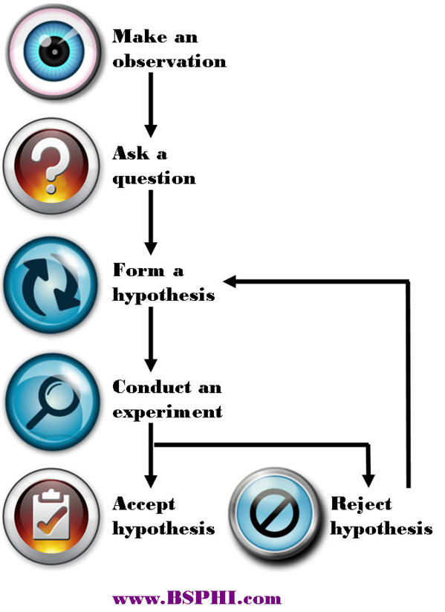
Use this site for help
http://www.sciencebuddies.org/science-fair-projects/project_scientific_method.shtml#overviewofthescientificmethod

Define the following terms:
Observation: X
Question: X
Hypothesis: X
Experiment: X
Conclusion: X

Define the skills needed to perform the scientific method

Reference: SW10 Pg4-5.

Make definitions of the main skills needed in the scientific method:
Observing: X
Recording: X
Inferring: X
Predicting: X
Generalising: X

Explain why the recording of data has to be truthful. X

Two other skills are RESEARCH and COMMUNICATING RESULTS. Explain why scientists would need to do these skills as well.
X

Watch this video of Edward Jenner, the English doctor who discovered vaccination.
http://www.youtube.com/watch?v=jJwGNPRmyTI

Describe how Jenner showed he was using the scientific method through:
Observing: X
Predicting: X

Practical investigations

Define the different types of variable

Reference: SW10 Pg 6-7

Use this site to define the different types of variable that occur in any experiment
http://www.sciencebuddies.org/science-fair-projects/project_variables.shtml

Independent Variable (IV): X
Dependent Variable (DV): X
Control Variable (CV): X

For an experiment to produce VALID results, it must be a FAIR TEST. Explain what makes an experiment a fair test. X

Go to this site for three different experiment situations:

http://wghsjuniorscience.weebly.com/experiments.html

For each experiment identify the independent, dependent and at least three control variables.

Experiment 1
IV: X
DV: X
CVs:
X
X
X

Experiment 2
IV: X
DV: X
CVs:
X
X
X

Experiment 3
IV: X
DV: X
CVs:
X
X
X

Write an aim and hypothesis

Reference: SW10 Pg 9

Each experiment has to have a reason to be done and that reason must be in the form of a test.

Define the terms
Aim: X
Hypothesis: X

For each of the three experiments, write an aim and a hypothesis.

Experiment 1
Aim: X
Hypothesis: X

Experiment 2
Aim: X
Hypothesis: X

Experiment 3
Aim: X
Hypothesis: X

Correctly tabulate data and draw and label appropriate graphs

Data tables
Data tables should follow the same format:
- The Independent Variable is in the left column.
- The results for all of the different trials for the Dependent Variable in the middle columns.
- The average for the Dependent Variable trials in the right column.

Explain why the Dependent Variable needs to have at least THREE trials. X

Explain why an average for the Dependent Variable is used. X

Draw up data tables using the results for Experiment 1 and Experiment 2 on this web page:

http://wghsjuniorscience.weebly.com/results.html

Graphs

Reference: SW10 Pg 10-11.

The type of graph you use depends on the type of data you have.
Discrete is either/or data e.g. type of animal, favourite colour, number of legs.
Continuous is a measurement e.g. height, weight, length, temperature, time.

Bar graphs are used when the Independent Variable is discrete data
Histograms are used when the Independent Variable is continuous but each measurement falls into a range of measurements e.g. height between 150-155cm.
Line graphs are used when the Independent Variable is continuous.

The line graph is the most commonly used type of graph.

To correctly draw a graph you must use TELLX
T: X
E: X
L: X
L: X
X: X

Using the data tables you produced before, draw graphs on graph paper. Make sure to use TELLX.

Line graphs can be used to make a prediction of a missing value. Describe the steps to making one of these predictions.
X

Interpret data to solve a given problem and make a generalisation

Conclusion
Your conclusion should include:
- The pattern in the data
- Proof of your pattern using some of the data you collected (this makes the conclusion VALID)
- Whether hypothesis is accepted or rejected

Make a conclusion for Experiment 1 and Experiment 2 based on the graphs you have made.

Experiment 1
X

Experiment 2
X

Generalisation
Generalisations are a rule that will happen in most situations and are based on experimental data.

Produce a generalisation for Experiment 1 and Experiment 2 which would be true for most situations.

Experiment 1
X

Experiment 2
X

Write up either Experiment 1 or Experiment 2 on paper and hand in to your teacher for marking.
Make sure you include:
- Aim
- Hypothesis
- List of Independent, Dependent and at least 3 Control Variables
- Table of results
- Correctly plotted and labelled graph
- Valid conclusion
- Generalisation

Carry out a practical investigation

During the year your teacher will give you the opportunity to perform investigations to practise what you have learned.

These investigations should be written up in your SciPad on pages xxx-xxx.

