**Speed vs Velocity** 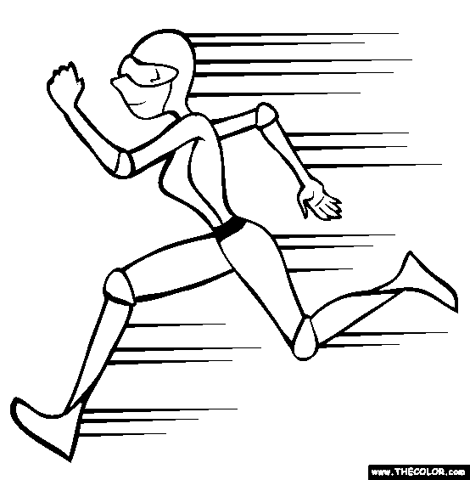

1. **Distance travelled (d) is “how far an object has actually moved”.**
2. **Displacement (d) is the shortest distance between the starting point and the finishing point.**
3. **Both are measured in metres (m).**

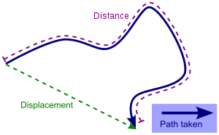

1. **Average speed (vav) is the distance travelled divided by the time taken (t).**
2. **Average velocity is the displacement divided by the time taken (direction is to be mentioned).**
3. **Both are measured in metres per second (ms-1) vav = d/t.**

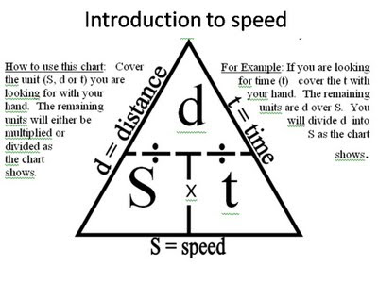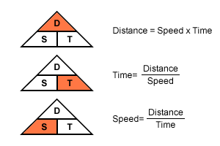

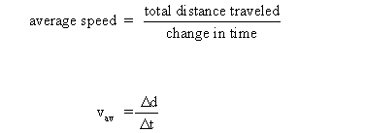

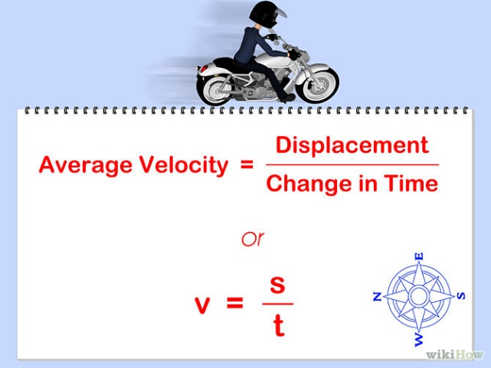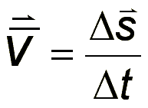

**Speed- Time Graph:** 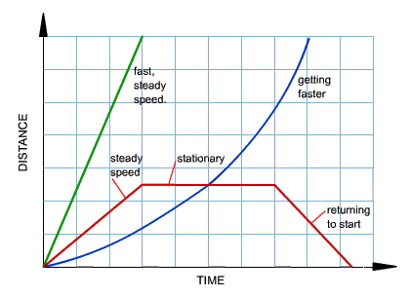

**ANSWER:**

**1. Describe the difference between "distance" and "displacement".**

**2. Describe the difference between "average speed" and "average velocity".**

**3. Calculate these and show complete working with formulae:**

**\*Pay attention to units and their conversion if needed.**

**a) If you run 100 m in 20 s, what is your speed?**

**b) Car travelled 1500 km with speed of 100 km/h. How long did it take?**

**c) If snail glides 12 cm/s for 5 s, how far did snail reach?**

**4. Interpret the journey from the graph:**

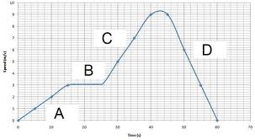

**A)**

**B)**

**C)**

**D)**

**Acceleration**

1. **When the velocity of an object changes it is said to accelerate and it is being acted upon by an unbalanced force.**

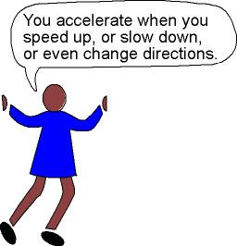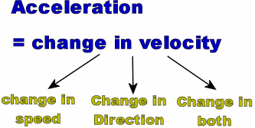

1. ***Acceleration (a) is the change in velocity measured in ms*-2**

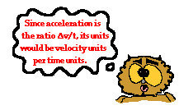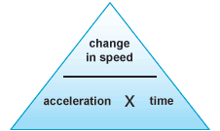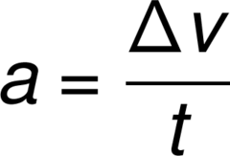

1. **a = ∆v/t. It can be positive (speeding up) or negative, sometimes called deceleration (slowing down).**

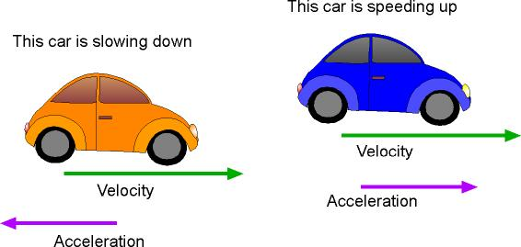

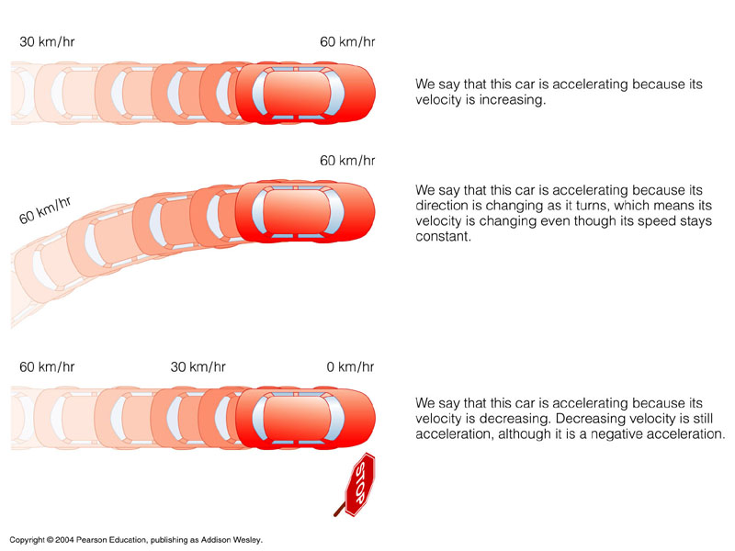

1. **F=ma. Unbalanced force will make the object accelerate in the direction of the force.**

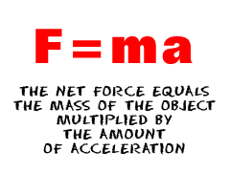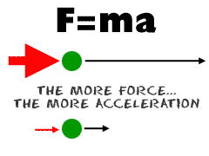

**REMEMBER:  Velocity vs Acceleration**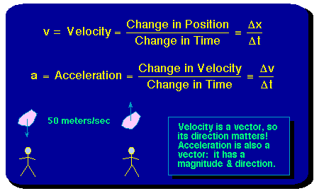

**Units: ms-1 vs ms-2**

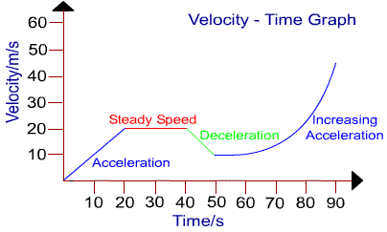

**ANSWER:**

**1. Define acceleration.**

**2. Explain the difference between velocity and acceleration.**

**3. What is causing acceleration?**

**4. Give three different ways with examples that object can accelerate.**

**5. Calculate and show complete working with formulae and units:**

**a) What is an acceleration of a shark that speeds up to 7 ms-1 in 4 seconds?**

**b) An apple falls from a tree on a ground with acceleration of 10 ms-2 within 0.3 s. What is the apple’s speed?**

**c) a Parachutist leaps of the cliff with an acceleration of 5ms-2 and reaches speed of 50 ms-1. How long does it take to reach this speed?**

**Forces Notes**

**Learning Objectives - to know:**

**What is a force?**

**How does Newton's Laws explain the motions of an object?**

**What is the correct use of SI units for speed, acceleration and force?**

**Force (F) has a unit Newton (N).**

Forces can be push (e.g.pushing a trolley) or pull (pulling open a door, tug of war).

Forces can be contact (e.g. push, pull and friction) or non-contact (e.g. gravity, magnetism, radiation, electrical force, nuclear force and static electricity).

**Newton Laws:**

**1.  If no unbalanced force is acting on an object its motion will not change (constant velocity)- inertia.**

**- e.g. Stationary satellites, parked car™**

**2. f an unbalanced force acts, then the object will accelerate in the direction of that force. F=ma and weight F=mg**

**- e.g. Car Speeding up,  Baseball, Cricket, Tennis ( player kicking Or hitting a ball )**

**3. If an object is at equilibrium (balance), all action forces must be balanced by an equal but opposite reaction force (action/reaction) (eg motive force vs friction)**

**- e.g. jumping on a trampoline, newton cradle, playing squash, Bow and arrow.**

**REMEMBER:**

1. **A moving object may or may not be acted upon by a force.**
2. **Balanced forces will not alter motion.**
3. **Unbalanced forces will cause acceleration / change motion.**

**Use appropriate SI units and ms-1 (m/s) type notation along with prefixes indicating order of magnitude, eg kilo (k) x 1000, centi ( c ) x 100, milli (m)x -1000.**

**TRY NOW:**

**1. Define a force and its unit of measurement:**

**2. Describe the different types of force that can be applied to an object and give examples:**

**a)**

**b)**

**c)**

**d)**

**e)**

**f)**

**g)**

**h)**

**3. Use Newton's Laws to describe the effect of a force on an object:**

**a) planets orbiting around the Sun -**

**b) car stopping at the red light -**

**c) boat is floating on the water -**

**d) forklift is lifting a pallet -**

**e) car is driving on the motorway at 90 km/h for an hour -**

**f)  submarine is diving in -**

**e) cat is sleeping -**

**4. Give example when forces change:**

**a) the shape of an object**

**b) the movement of an object**

**c) the speed of the object**

**5. Define balanced and unbalanced forces:**

**a)**

**b)**

**6. Calculate net forces and it’s direction:**

**a) Trolley is pushed forward with a force of 75 N by one person, but is pulled backward with a force of 45 N by another person.**

**b) Trolley is pushed forward with a force of 35 N by one person and 30 N by other person, while it is pulled backward with a force of 65 N by a third person.**

**6. Use appropriate SI units correctly:**

**Mass is measured in …….  (      ). Thousand part of it is …….. (     ), and thousand  …… is one …….. (    ).**

**Distance is measured in …….  (      ). Thousand part of it is …….. (     ), and thousand  …… is one …….. (    ).**

**Force is measured in …….  (      ).**

**Time is measured in …….  (      ). Larger unit is …….. (     ), while smaller unit is  …… is one …….. (    ).**

**Speed is measured in …….  (      ).**

**Acceleration is measured in …….  (      ).**

**Force, Mass and Acceleration**

1.

|  |  |  |
| --- | --- | --- |
| Force (N) | Mass (kg) | Acceleration (ms-2) |
|  | 5 | 2 |
|  | 0.2 | 5 |
| 20 |  | 4 |
| 2700 |  | 15 |
| 50 | 10 |  |
| 4 | 0.2 |  |

2. A toy truck of mass 0.4kg accelerates at 0.5ms-2 when a constant force is applied. What is the size of the pulling force?

3. An apple with a mass of 0.5g was dropped with a force of 5N. Calculate its acceleration.

**Mass and Weight**

**MASS: is the amount of matter (substance) in the object.**

**WEIGHT: is the force of gravity acting on a mass.**

**Unit for mass is kilogram (kg) and unit for weight is Newton (N).**

**Mass is measured with balance and weight with spring balance.**

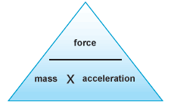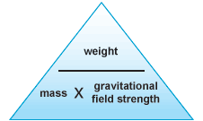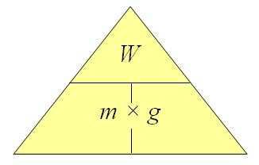

**Write down the following formulae by using above formula triangles:**

**F =                m=                    a=**

**W=                m=                    g=**

**Rewrite the same formulae by inserting appropriate units instead of quantities, e.g. N (Newtons) instead of F (Force) etc.**

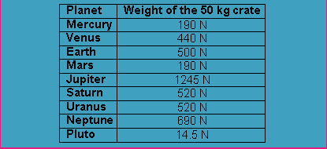

This is a table of 50 Kg crate weight values on different planets.

ANSWER:

1. What is the mass of the crate?
2. Explain what happens to the mass of the crate on different planets.
3. Why are there different weight values for the same crate?
4. Can you calculate the force of gravity on different planets from the table above?

YOUR TASK IS TO EXCHANGE EVERY PICTURE CLIP WITH AN APPROPRIATE WORD IN THE TEXT BELLOW.

*C:\Users\bbiondic\AppData\Local\Microsoft\Windows\Temporary Internet Files\Content.IE5\WUWAV0VE\MC900105206[1].wmf***Forces Summary:** *C:\Users\bbiondic\AppData\Local\Microsoft\Windows\Temporary Internet Files\Content.IE5\OBBWMWKK\MC900105204[1].wmf*

A **force** (F) is a push or a pull. Its unit is C:\Users\bbiondic\AppData\Local\Microsoft\Windows\Temporary Internet Files\Content.IE5\WUWAV0VE\MC900197956[1].wmf.

Forces can be contact (push, pull or C:\Users\bbiondic\AppData\Local\Microsoft\Windows\Temporary Internet Files\Content.IE5\2L5OU3K1\MC900363788[1].wmf) or non-contact (magnetism, electrostatic, gravitational).

***Newton’s Laws:***

  · If no unbalanced force is acting on an object its motion will not change and it will continue to move with C:\Users\bbiondic\AppData\Local\Microsoft\Windows\Temporary Internet Files\Content.IE5\OBBWMWKK\MC900384116[1].wmf: **inertia.**

  · If an unbalanced force acts, then the object will accelerate in C:\Users\bbiondic\AppData\Local\Microsoft\Windows\Temporary Internet Files\Content.IE5\WUWAV0VE\MC900136669[1].wmfof that force **F=ma** and C:\Users\bbiondic\AppData\Local\Microsoft\Windows\Temporary Internet Files\Content.IE5\07WNL8S6\MC900446532[1].wmf **F=mg**

  · If an object is at equilibrium, all action forces must be C:\Users\bbiondic\AppData\Local\Microsoft\Windows\Temporary Internet Files\Content.IE5\OBBWMWKK\MC900214917[1].wmf by an equal but opposite reaction force **(action/reaction)** (e.g. motive force vs. friction).

A moving object may or may not be acted upon by a force.

Balanced forces will not alter motion.

C:\Users\bbiondic\AppData\Local\Microsoft\Windows\Temporary Internet Files\Content.IE5\07WNL8S6\MC900286986[1].wmf forces will cause acceleration (change of speed), change of direction or change of shape of an object.

Forces are C:\Users\bbiondic\AppData\Local\Microsoft\Windows\Temporary Internet Files\Content.IE5\GXGSE594\MC900441946[1].wmf: they have direction and magnitude (size) and can be presented by arrows.

DistanceC:\Users\bbiondic\AppData\Local\Microsoft\Windows\Temporary Internet Files\Content.IE5\07WNL8S6\MC900071065[1].wmf (d) is “how C:\Users\bbiondic\AppData\Local\Microsoft\Windows\Temporary Internet Files\Content.IE5\KPRXIU3Q\MC900198104[1].wmf an object has actually moved” while C:\Users\bbiondic\AppData\Local\Microsoft\Windows\Temporary Internet Files\Content.IE5\GXGSE594\MC900128675[1].wmf (d) is the shortest distance between the starting point and the finishing point. Both are measured in C:\Users\bbiondic\AppData\Local\Microsoft\Windows\Temporary Internet Files\Content.IE5\2L5OU3K1\MC900234193[1].wmf (m).

Average C:\Users\bbiondic\AppData\Local\Microsoft\Windows\Temporary Internet Files\Content.IE5\SRLDGQ9E\MC900363816[1].wmf (vav) is the distance travelled divided by the time taken (t), **average velocity** is the displacement divided by the time taken (direction is to be mentioned) both are measured in metres per second (ms-1) **vav = d/t.**

C:\Users\bbiondic\AppData\Local\Microsoft\Windows\Temporary Internet Files\Content.IE5\SRLDGQ9E\MC900441910[1].wmf work will be advanced to v/t graphs and comparison, interpretation of d/t vs. v/t.

When the **velocity** of an object changes it is said to **accelerate** and it is being acted upon by an C:\Users\bbiondic\AppData\Local\Microsoft\Windows\Temporary Internet Files\Content.IE5\SRLDGQ9E\MC900446512[1].wmf **force**.

***Acceleration*** *(a) is the change in velocity measured in ms*-2**a =** ∆**v/t**.

It can be C:\Users\bbiondic\AppData\Local\Microsoft\Windows\Temporary Internet Files\Content.IE5\WUWAV0VE\MC900139391[1].wmf (speeding up) or C:\Users\bbiondic\AppData\Local\Microsoft\Windows\Temporary Internet Files\Content.IE5\SRLDGQ9E\MC900056713[1].wmf, sometimes called deceleration (slowing down).

F=ma. Unbalanced force will make the object accelerate in the C:\Users\bbiondic\AppData\Local\Microsoft\Windows\Temporary Internet Files\Content.IE5\WUWAV0VE\MC900390986[1].wmf of the force.

C:\Users\bbiondic\AppData\Local\Microsoft\Windows\Temporary Internet Files\Content.IE5\07WNL8S6\MC900290466[1].wmf is the amount of matter in an object measured in kilograms and does not change.

C:\Users\bbiondic\AppData\Local\Microsoft\Windows\Temporary Internet Files\Content.IE5\SRLDGQ9E\MC900292460[1].wmf is the force (Fw) of an object under the influence of C:\Users\bbiondic\AppData\Local\Microsoft\Windows\Temporary Internet Files\Content.IE5\GXGSE594\MC900082475[1].wmf. This will change with proximity to another mass (Earth, Moon, space etc.) or with a change of position.

*You must understand use of appropriate* ***SI*** *units and ms-1 type of scientific notation, along with prefixes indicating order of magnitude, e.g. kilo (k), centi (c), milli (m).*

C:\Users\bbiondic\AppData\Local\Microsoft\Windows\Temporary Internet Files\Content.IE5\2L5OU3K1\MC900078805[1].wmf C:\Users\bbiondic\AppData\Local\Microsoft\Windows\Temporary Internet Files\Content.IE5\07WNL8S6\MC900233844[1].wmf C:\Users\bbiondic\AppData\Local\Microsoft\Windows\Temporary Internet Files\Content.IE5\WUWAV0VE\MC900078806[1].wmf 