MATERIAL WORLD – MATTER
Electronic Science LabBook
Designed by HMG and FHR

When you are required to put an answer in this booklet, the point at which you start typing is marked with a red X. Your typed answer should also appear in red. Delete the X leaving just your answer.
If you are required to paste or draw something, this is stated in BLUE. You can then photograph your work and paste it into this LabBook. In many experiments and investigations, you will be asked to photograph or video the experiment. You should insert these in the appropriate place in this LabBook.
When you are asked to look at a website for information to write an answer don’t just cut and paste the information in. Read the information and write an answer in YOUR OWN WORDS. You may wish to discuss your answer with your classmates and teacher first to make sure you understand it correctly.
For additional work (e.g. homework, revision) you will use the following books. You will be told which pages to use.
- SciPad – pages 48-67
- Science World 9 textbook (written as SW9) – chapter 3, pages 36 – 58.

Learning outcomes for this topic

The three states of matter
- Describe the three states of matter
  - Task 1
  - Task 2
  - Task 3
  - Task 4
- Describe and explain changes in state, linking to heating and cooling
  - Task 5
  - Task 6
  - Task 7
The particle theory of matter
- Describe the kinetic theory of matter
  - Task 8
  - Task 9
- Link the kinetic theory of matter to the three states of matter
  - Task 10
  - Task 11
  - Task 12
  - Task 13
Explain the properties of matter
- Describe some physical properties of matter
  - Task 14
  - Task 15
  - Task 16
- Understand that density is mass per unit volume and use formula density=mass/volume
  - Task 17
  - Task 18
  - Task 19
- Link density to floating and sinking.
- Explain expansion and contraction as a change in density
- Link expansion and contraction of a substance to heating and cooling, the kinetic theory of matter and the three states of matter
- Explain some uses and problems associated with expansion and contraction
  - Task 20
- Know that different substances expand/contract at different rates
  - Task 21
  - Task 22
- Link diffusion of a substance to the kinetic theory of matter
  - Task 23
  - Task 24
  - Task 25
  - Task 26
  - Task 27

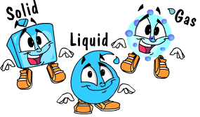
The three states of matter

Describe the three states of matter

Reference: SW9 Pg 37

Task 1
Everything around us is made of matter. Take pictures of 3 objects around the school- you have only 5 min. Insert these pictures in the table below

Task 2
Measure the mass using the electronic balance and calculate the volume. Fill in the table below X

Object name | Estimated mass | Measured mass | Calculated volume (l x b x h)
Small Book
Tissue box
White board duster

All matter has X and occupies X

All matter can be organised into 3 states of matter - X, X and X

Task 3
Watch the video http://www.youtube.com/watch?v=bMbmQzV-Ezs
And go through this website
http://www.bbc.co.uk/bitesize/ks3/science/chemical_material_behaviour/particle_model/revision/1/

Task 4
Experiment on properties of the 3 states of matter, see text book. SW9 Pg38.
Perform experiment
Fill in the table X
States  of  matter | Properties
 | Can be weighed | Occupy space | Fixed shape | Fixed volume | Can be compressed
Solids | √
Liquids | √
Gases | √

Describe and explain changes in state, linking to heating and cooling

Reference: SW9 Pg 45

Task 5
Find a diagram showing how we can change between the three states of matter and paste it here

Task 6
The table below lists five changes of state. For each change decide whether heating or cooling is needed. Place a tick ( √ )in the correct column and fill in final column. X
Change of state | Heating | Cooling | Energy taken in or energy released
Solid to liquid
Liquid to gas
Liquid to solid
Gas to liquid
Solid to gas

The boiling point of water is X °C, whereas the melting point of water is X °C.

What is the physical state of water at these temperatures?
45 °C X
125 °C X
-23 °C X
75 °C X

Task 7
Here are the melting and boiling points of some elements. What state are they at 25 °C?

Element | m.p.(⁰C) | b.p. (⁰C) | State at 25⁰C
Chlorine | -101 | -34 | X
Iodine | 114 | 184 | X
Fluorine | -220 | -188 | X
Bromine | -7 | 59 | X

The particle theory of matter

Describe the kinetic theory of matter
Reference: SW9 Pg 46-49
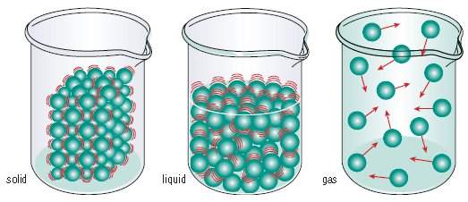

Task 8
Go to http://library.thinkquest.org/C0110228/molecules/kinetic.htm and http://everythingscience.co.za/grade-10/03-states-of-matter/03-states-of-matter-02.cnxmlplus
and summarise the main points about the kinetic theory of matter
X
Go to http://www.youtube.com/watch?v=Y8j6peP5nNg which is a youtube video (5 mins) to help explain the kinetic theory of matter
Go to http://phet.colorado.edu/en/simulation/states-of-matter-basics which is an excellent for simulations (as shown in the youtube video above)

Task 9
Practice writing long answers: put your ideas together about solid/ liquid/gas in to 3 paragraphs.. The solid part is done for your – you need to write descriptions for the liquid and gas
States | Solid | Liquid | Gas
Description | Particles are arranged in a regular way and are very close together. There are strong attractive forces holding the particles together in a fixed position. The particles have a small amount of energy and can only vibrate. They are unable to move freely.

Temperature of the substance is related to the average X (two words) of particles.
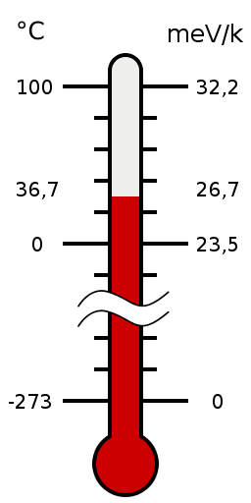
For particles to theoretically stop moving, they have to be cooled to -273.15°C. This temperature is called X (two words)

For experts –
go to http://www.youtube.com/watch?v=28F_oPDZHSk
and http://www.youtube.com/watch?v=TNUDBdv3jWI
(this will NOT be tested)

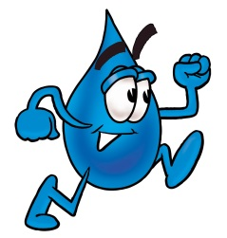
Link the kinetic theory of matter to the three states of matter

Change of state
- When substances are heated or cooled, a change of state may occur.
- This is a physical change as a new substance has not been formed, a physical property of the substance has changed.
- We can use particle theory to explain changes of state.

Task 10
Fill in the process names:
X

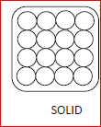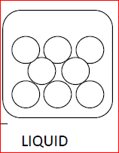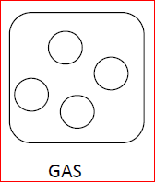
X

X

X

X

X

http://www.docbrown.info/page03/3_52states/3_52statesQ.htm

Explaining melting (solid-liquid) in terms of the kinetic theory of matter
When a solid is heated the particles gain more kinetic energy and vibrate faster.
At the melting point the particles have gained so much energy and vibrate so much that they are moving fast enough to overcome the forces of attraction between the particles and move far enough apart so that they can slide past each other. When this happens the solid becomes a liquid.

Task 11
Explain what happens when water boils. (the quality of answer required is modelled above)
In your answer include the concepts of moving particles, energy, forces of attraction, distance between particles.
X

Task 12
Experiment on heating ice until it boils, see textbook SW9 page 49+50
Perform the experiment
Complete the table: X
Time (min) | 0 | 0.5 | 1.0
Temp(⁰C)

Graph your results: X

Answer the ‘Questions and Conclusions’ and the ‘Challenge’ on page 50 X

States of Matter Task: use 3 colours to group statements about the three states of matter.

Task 13
One statement in each column highlighted in magenta is done for you - there are other characteristics that also belong to the solid state, highlight them in magenta as well.
Highlight all the statements about liquids in green
Highlight all the statements about gases in yellow

Solid Liquid Gas

Arranged in rows | Not able to change places | Spread to fill container
Takes on the shape of the container | Not arranged in any particular way | Fixed shape
Examples of Solids =  - Ice,  - Table,  - Pencil, | Examples of Gases=  - Oxygen,  - Carbon Dioxide,  - Sulfur Dioxide, | Move about and change places
Relatively close together | Not held together as tightly as solids | Fixed volume
Can be easily compressed | Particles are far apart | Very weakly held together
Particles are held close together tightly | Particles Flow | Move very fast in all directions
Particles vibrate | Solid | Examples of Liquids=  - Water,  - Juice,  - Coffee,
 | Gas

Explain the properties of matter

Describe some physical properties of matter

Task 14
Watch the video /presentation, then complete this table
Properties | Meaning
State
Colour
Density
Solubility
Malleability
Shape
Mass
Volume
Melting point
Boiling point
Conductivity

This is a song about physical properties:
http://www.youtube.com/watch?v=uJOGy0dgmUU&list=PL1B5C9748DDFF1499

Task 15
Explaining the properties of matter in the three states of matter
Why do solids, liquids and gases have their own distinct properties? Let’s look at them at microscopic level.

Homework, please preview these websites before you come to class.
http://www.chem.purdue.edu/gchelp/liquids/character.html
http://www.youtube.com/watch?v=s-KvoVzukHo
http://www.bbc.co.uk/bitesize/ks3/science/chemical_material_behaviour/particle_model/revision/2/

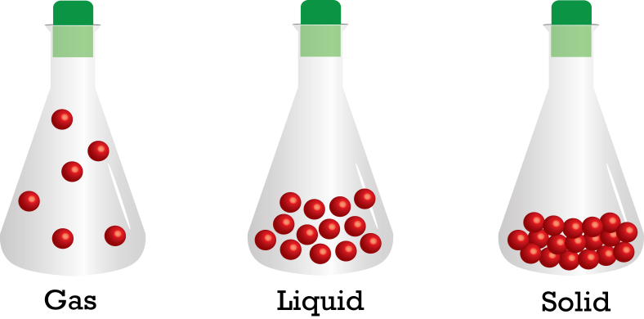
Explaining properties:

Task 16
Put down your ideas about how
particles in each state are arranged,
the strength of attraction forces
and how they move around.

State | Solid | Liquid | Gas
The arrangement of the particles
(regular or irregular)
distance between particles
(small or large)
Strength of attractive forces between particles
(strong or weak)
Speed of particles
(fast or slow)
Example in pictures

Answer the following in small paragraphs:
1) Explain why air is able to be compressed? X

2) Explain why we can pour liquid and gas but not solid? X

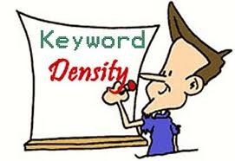
Understand that density is mass per unit volume and use the formula density=mass/volume

Link density to floating and sinking.

Density is how much mass is packed in to a measured volume. Density tells us something about how tightly packed the particles are in a substance. The following is a table showing the density of some substances.

substance | 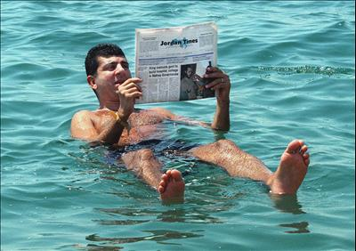  Density (g/cm³)
air | 0.0013
cork | 0.2
ice | 0.9
water | 1.0
aluminium | 2.7
iron | 7.8
lead | 11.3
mercury | 13.5
gold | 19.3

A substance will float in water if its density is less than the density of water; while a substance will sink in water if its density is greater than the density of water
Name two substances that will float in water. X
Name two substances that will sink in water. X
Name a substance that will sink in water but float in mercury.X
Look up the average density of the human body X
Explain why the man in the photograph above is able to float in the Dead Sea (in the Middle East)? X

Task 17
Explain why we use aluminium rather than iron to make air plane parts? X
Go to the simulation at http://phet.colorado.edu/en/simulation/density and investigate what is happening.

Calculating density
If we know the mass and the volume of a substance, we can calculate its density by using the formula
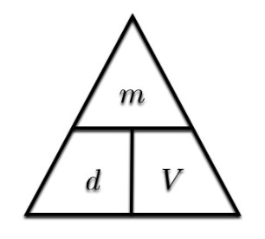
density = mass/volume
mass = density x volume
volume = mass / density

Task 18
Experiment on measuring density
Reference: SW9 page 41

Note that 1mL = 1 cm³
Object | Mass (g) | Initial volume (mL) | Final volume (mL) | Volume of object (mL) | Density (g/cm³)
pebble | 10.5 g | 10.0 mL | 12.6mL | 12.6mL-10.0mL  = 2.6 mL  (or 2.6 cm³) | d = m/V  = 10.5/2.6  = 4.04 g/cm³
X
X
X

When you do calculations you MUST:
- Show the formula you are using
- Show the numbers you are using
- Calculate the answer
- Give units for the answer

Task 19
- If you know that a small piece of gold has a mass of 20g and a density of 19.3 g/cm³, calculate its volume.
X
- If you know that a small piece of aluminium has a volume of 50cm3 and a density of 19.3 g/cm³, calculate its mass.
X

Explain expansion and contraction as a change in density

Link expansion and contraction of a substance to heating and cooling, the kinetic theory of matter and the three states of matter

Expansion & Contraction
Reference: SW9 Pg 55

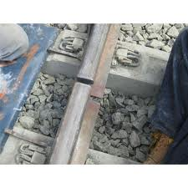
Substances expand or get bigger when they are heated up. Substances contract or get smaller when they are cooled down. This property can be useful e.g. the liquid in thermometers expands and occupies more space, so the liquid rises up the thermometer.
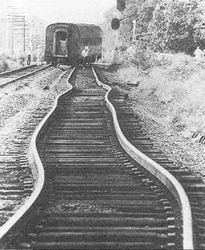
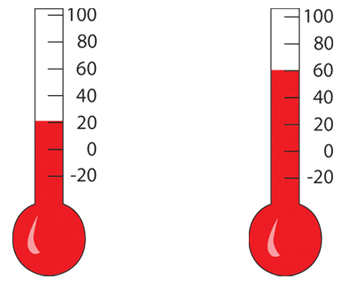

Materials expanding and contracting can also cause problems e.g. railway lines expand in the summer heat and need special joints to stop them bending out of shape.

What do the particles do
When substances expand or contract, their particles stay the same size. It is the space between the particles that changes:
The particles in a solid vibrate more when it is heated, and take up more room
The particles in a liquid move around each other more when it is heated, and take up more room.
The particles in a gas move more quickly in all directions when it is heated, and take up more room.

Solids, liquids & gases all expand (get larger) when heated. When they are cooled they contract (get smaller).
As a solid is heated the particles gain e and vibrate more violently and start to bump in to each other. This causes them to move further a so that they have more s, therefore the solid as a whole ex.
When a solid expands, the mass stays the same, but the v increases, therefore what will happen to the density? X

When the solid is cooled the particles lose e and vibrate more slowly. This causes them to slow down, move c together and occupy less s, therefore the solid as a whole c .
When a solid contracts, the mass stays the same but the v decreases, therefore what will happen to the density? X

Water is an exception !! - find out about the expansion of water. X

Explain some uses and problems associated with expansion and contraction

Look at the following pictures pictures – the harbour bridge (a metal bridge), a join in the structure of the harbour bridge and power lines in summer.
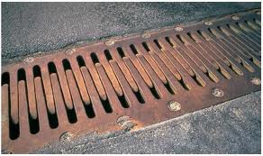
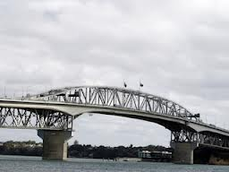

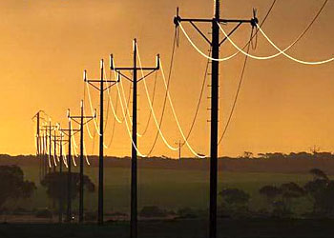

Task 20
- Explain why the harbour bridge requires finger-like joins in the bridge structure. Explain what would happen in summer when it is hot and in winter when it is cold.
X

- Explain why the power cables, which are made of metal, droop so much in summer when it is hot. Describe and explain what would happen in winter when it is cold.
X

Know that different substances expand/contract at different rates

Task 21
Experiment on Bimetallic strip (solid metals of different types):
Take a picture and insert here and then describe and explain your observation:
Picture | Explanation X

Experiment on ball and ring (solids):
Take a picture and insert here and then describe and explain your observation:
Picture | Explanation X

Demonstration of coloured water in a tube(liquid):
Take a picture and insert here and then describe and explain your observation:
Picture | Explanation X

Demonstration of balloon on top of flask (gas)
Take a picture and insert here and then describe and explain your observation:
Picture | Explanation X

Some interesting facts
- When liquids and gases get hot they expand, just as solids do. When heated by the same amount, liquid expands about 10 times more than solids, and gases expand about 1000 times more than liquids.
- Different substances expand and contract by different amount.
- Water is an exception, when it is heated, it expands, but when it is frozen, it also expands.
- All gases expand at the same rate

Task 22
Watch the collapsing can experiment - video http://www.youtube.com/watch?v=FjYB8hgkvOU
Explain how it works - Use particle theory, including particles/ kinetic energy/forces/density. X

Watch videos about hot air balloons- video http://www.youtube.com/watch?v=Ev9xlnWseyw
and http://www.youtube.com/watch?v=wBAes6MMa40
Explain how a hot air balloon can rise? Use particle theory, including particles/ kinetic energy/ forces/density. X

Link diffusion of a substance to the kinetic theory of matter

Reference: SW Pg 53,54

Task 23
Definition: Diffusion is X

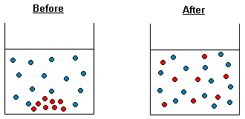
Watch http://www.youtube.com/watch?v=VY0mZUDvbH4
and http://www.youtube.com/watch?v=KRLNDTmBFZY

Demonstration of diffusion of gases (teacher only demo , hazardous substances used)

Watch http://www.youtube.com/watch?v=S9yuoLkfI3E
and http://www.youtube.com/watch?v=L41KhBPBymA

Explain the formation of the ‘white smoke’ X
Which gas moved faster? X Explain your answer X
Demonstration of diffusion in liquids (teacher only demo , leave for a few weeks)
Place some water in a large measuring cylinder. Add about 50mL of dilute acid and some universal indicator. Leave to settle. Then drop in large crystals of sodium carbonate (washing soda) and drop in a little more acid carefully. Leave it to settle and observe every day
Take a photograph and place it here

Explain what is happening X

Task 24
Experiment to show diffusion in liquids
Place some water in a large petri dish and let it become very still. Place a few crystals of potassium iodide at one side and a few crystals of lead nitrate on the opposite side. Watch until something happens. Take a photograph and place it here

Explain what has happened. X

In biology, we get diffusion of substances through membranes – the membranes have tiny holes in them through which the substance can move.
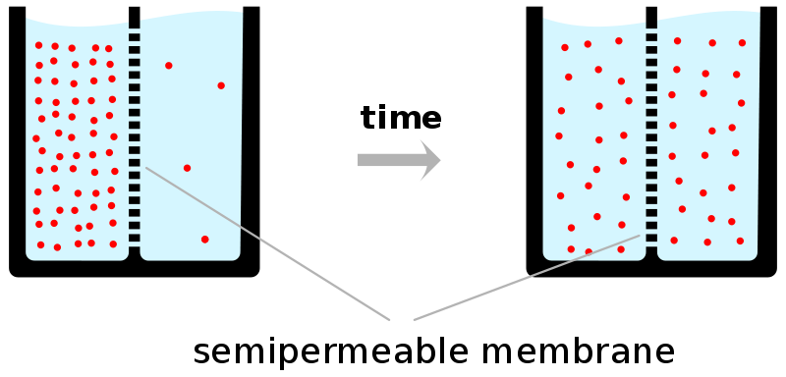

The movement of water through a semi-permeable membrane is given a special name - it is called X.

Watch http://www.youtube.com/watch?v=OXCKjhE1xco diffusion and osmosis in cells
Watch http://www.youtube.com/watch?v=wyJyDvQ6zaI to illustrate osmosis in raisins
Go to the simulation at http://phet.colorado.edu/en/simulation/membrane-channels and investigate what is happening.

Task 25
Experiments with Dry Ice (solid carbon dioxide)

Experiment 1: Put dry ice in a balloon.
Observation and explanation: X

Experiment 2: Put a piece of dry ice into a film canister.
Observation and explanation: X

Experiment 3: Put a piece of dry ice into a beaker with a little water in it.
Observation and explanation: X

Experiment 4: Pour the gas from experiment 3 into another beaker and put a lit splint into it.
Observation and explanation: X

Experiment 5: Put some water into a beaker with a little bit of universal indicator in it along with a piece of dry ice.
Observation and explanation: X
.

Task 26
Practising comparison explanations:
Step 1: write a general statement (a topic sentence) about solids, liquids and gases.
X

Step 2: write a sentence or two comparing and contrasting the distance between particles.
X

Step 3: write a sentence or two comparing and contrasting the forces between particles.
X

Step 4: write a sentence or two comparing and contrasting the speed of the particles.
X

Task 27
Compare and contrast the difference between evaporating and boiling in a paragraph.
Use a contrasting linking word from here: (whereas, even though, but, while, less than, although, unlike, yet, however, different from, whilst…)
X

