LIVING WORLD – PLANTS
Electronic Science LabBook
Designed by BLU and HMG

When you are required to put an answer in this booklet, the point at which you start typing is marked with a red X. Your typed answer should also appear in red. Delete the X leaving just your answer.
If you are required to paste or draw something, this is stated in BLUE. You can then photograph your work and paste it into this LabBook. In many experiments and investigations, you will be asked to photograph or video the experiment. You should insert these in the appropriate place in this LabBook.
When you are asked to look at a website for information to write an answer don’t just cut and paste the information in. Read the information and write an answer in YOUR OWN WORDS. You may wish to discuss your answer with your classmates and teacher first to make sure you understand it correctly.

For additional work (e.g. homework, revision) you will use the following books. You will be told which pages to use.
- SciPad
- Science World 9 textbook (written as SW9)

Learning outcomes for this topic

The life cycle and structure of a plant
- Understand the life cycle of a plant
  - Task 1
- Describe the structure and function of parts of the plant
  - Task 2
- Describe the transport of water through a plant
  - Task 3
  - Task 4
  - Task 5
  - Task 6

The importance of leaves
- Describe the process of photosynthesis
  - Task 7
- Explain the importance of photosynthesis
  - Task 8
  - Task 9
- Explain the importance of food storage
  - Task 10
  - Task 11
- Explain the structure of the leaf, and adaptations for photosynthesis
  - Task 12
  - Task 13
  - Task 14

The importance of flowers
- Explain the importance of sexual reproduction
  - Task 15
- Describe and explain the structure of a flower
  - Task 16
  - Task 17
- Describe pollination and pollinators
  - Task 18
  - Task 19
- Distinguish between pollination and fertilisation
  - Task 20

The importance of seeds
- Describe the structure of a seed
  - Task 21
  - Task 22
- Explain the need for seed dispersal
  - Task 23
- Explain the requirements for germination of seeds
  - Task 24
  - Task 25
  - Task 26

The importance of plants to all life on our planet
- Discuss the relationship between energy from the sun, the process of photosynthesis and the requirements for life
  - Task 27

The life cycle and structure of a plant

Understand the life cycle of a plant

Reference: SW9 Pg 121
Plants go through a life cycle like all other living things. There is no start or end to the cycle.

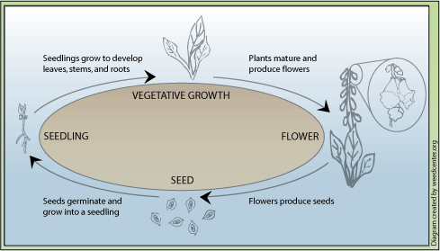

Task 1
Seeds are dormant. What does this mean the seed is doing? Find out using the internet and write an answer in your own words.
X

Why would seeds need to be able to do this?
X

Plants are important because they provide food and oxygen but also because humans use them to make things.

SciPad Pg 132

Describe the structure and function of parts of the plant

There are two main systems in a plant:
- The root system is below the ground
- The shoot system is above the ground

Task 2
Label the diagram of the plant:
Terms to use: Flower, Fruit, Leaf, Root, Stem.
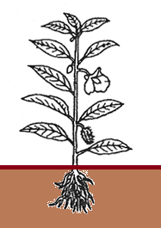
2
1
5
4
3

What is the name and functions for each part of the plant numbered 1 to 5 in the diagram?
1. X
2. X
3. X
4. X
5. X

SciPad Pg 122-123

Describe the transport of water through a plant

Water is important for a plant. It needs water for:
- photosynthesis
- chemical reactions in its cells
- support (to keep it upright and stiff)
- keep leaves cool

Plants get water throughout their body by a process called transpiration.

Task 3
Watch this video to answer the following questions (pause the video while you write your answers, you may need to watch it a few times)
http://www.youtube.com/watch?feature=player_embedded&v=At1BJJDcXhk
Use this picture for extra help: http://image.wistatutor.com/content/feed/u2044/Diagrammtic%20representation%20of%20Transpiration-Cohesion%20Theory.jpeg

Where does the water originally come from?
X
Where does the water enter the plant?
X
What is the name of the tubes that the water moves up the stem called?
X
Where does the water come out of the plant?
X
What is the name of the pores (little holes) where the water is coming out?
X

Task 4
Put a stick of celery into a beaker of water with food colouring added to it. Take a photo of it at the start and another the next day. Cut it across the stem and take a photo.
Paste your photos here.

Do Pg 130 in your SciPad

Task 5
How fast transpiration occurs (the rate of transpiration) depends on what is happening in the environment. Use this animation to name the FOUR things which could change the rate of transpiration. *This is a flash animation so iPads might not be able to play it. Share with someone who can play it.
http://www.sciencemag.org/site/feature/misc/webfeat/vis2005/show/transpiration.swf

1. X
2. X
3. X
4. X

Task 6
Write a short paragraph to summarise your understanding of transpiration. Include
- a definition of transpiration
- how transpiration works
- why the plant needs transpiration to happen
- what can speed up the rate of transpiration
X

Paste in a diagram showing the transport of water through a plant.
X

The importance of leaves

Describe the process of photosynthesis

Reference: SW9 Pg 255

All plants (and some protists) can do photosynthesis!

Task 7
Watch the following video
http://www.youtube.com/watch?v=C1_uez5WX1o
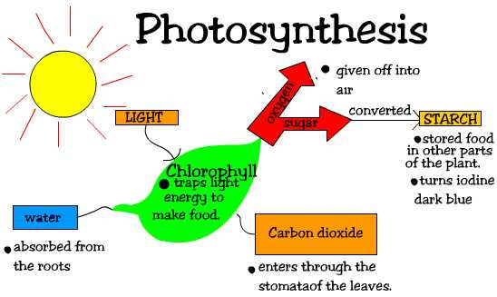
Using the video and the picture, complete the word equation for photosynthesis
X
X
X
X
chlorophyll
light
+
+

Where have the reactants (the chemicals/energy) needed for photosynthesis come from?
Water X
Carbon dioxide X

What happens to the products (chemicals made in the reaction) of photosynthesis?
Oxygen X
Sugars X (The scientific term for the sugar produced is GLUCOSE)

Where in the plant does photosynthesis occur? X

What part of the plant cell contains the chlorophyll needed to make photosynthesis happen? X

Where does the light come from? X

SciPad Pg 124-125

Explain the importance of photosynthesis

Photosynthesis is the only way energy can be turned into food. This means that all living organism rely on photosynthesis in order to get energy in the form of food. Animals and fungi need to eat other organism to get their energy but plants can make their own.

Task 8
Think of eating a hamburger. Where has the energy from the different ingredients come from? How can each ingredient be tracked back to a plant?
e.g. Bread bun – made from plant (flour is ground up seeds)
Beef patty – X
Tomato – X
Lettuce – X
Cheese – X

Task 9
Write a paragraph discussing how photosynthesis works and why it is important to life. Include
- a definition of photosynthesis
- what is needed
- what is produced
- a word equation showing photosynthesis
- why all living things rely on it
X

Explain the importance of food storage

Reference SW9 Pg 263-264

Task 10
Watch this video
http://www.youtube.com/watch?v=r-z7hbCFI2o

The glucose that plants make can easily dissolve in water. Leaves make the glucose but other parts of the plant need it as well in order for the cells to get energy.

What is the name of the vessels that take the glucose from the leaves to the rest of the plant? X

What substance can glucose be converted into? X

Look this substance up on the internet. Does it dissolve in water? X

This means it can be stored in parts of the plants. Plants make lots more glucose than they actually need. By storing the extra glucose, they can use this to produce flowers; grow; survive when little light is available and other things which require a lot of energy.

Task 11
If you put iodine solution on starch, it will turn a dark blue-black colour. Place a couple of drops of iodine on carrot, potato and onion. Take photos and paste them here:
X

Food is stored in the following parts of a plant:
X example:
X example:
X example:

Explain the structure of the leaf, and adaptations for photosynthesis

Leaves are designed to make the most amount of glucose by photosynthesis as possible.

Task 12
Explain why leaves have these adaptations to allow maximum photosynthesis
Thin X
Large X
Green colour X

Look at http://en.wikipedia.org/wiki/Leaf and http://www.bbc.co.uk/schools/gcsebitesize/science/add_edexcel/organism_energy/photosynthesisrev1.shtml

Task 13
Past in a cross-section diagram of a leaf

Complete the table below

Part of leaf | Brief structure and Function
Waxy cuticle
Upper epidermis
Palisade layer
Spongy mesophyll
Stomata and guard cells
Vein
Lower epidermis

SciPad Pg 123, 128

Task 14
How important is chlorophyll and sunlight to photosynthesis?
Experiment, SciPad Pg 126-127

Take a photo of the results from your leaf and paste it in. Label it with:
- areas that had chlorophyll at the start
- areas that had no chlorophyll at the start
- area that had light blocked from it

If there was photosynthesis taking place, then glucose was made. This would be converted into starch which turns blue-black with iodine.
Was starch made where there was?
- chlorophyll and light? X
- chlorophyll but the light was blocked? X
- light but no chlorophyll? X

What conditions did the leaf need in order for photosynthesis to occur?
X

The importance of flowers

Explain the importance of sexual reproduction

Task 15
Use this website to get information in order to complete the paragraph:
http://www.biotopics.co.uk/genes1/asexual_and_sexual_reproduction.html
In some cases the first letter has been given to you.

Sexual reproduction requires X parents (X and X). In sexual reproduction two special cells called g fuse together to make new offspring. The offspring they produce are genetically X. This means that the offspring have genetic v. This allows some individuals to survive if the environment changes, allowing the species to survive and allows for e to happen. However, this process is s and takes lots of energy.

Describe and explain the structure of a flower
Reference: SW9 Pg 116

Task 16
The flower is the sexual reproduction organs in a plant.
Use this site to help you label the diagram
http://www.familymanagement.com/holidays/flowers/flower_anatomy.html
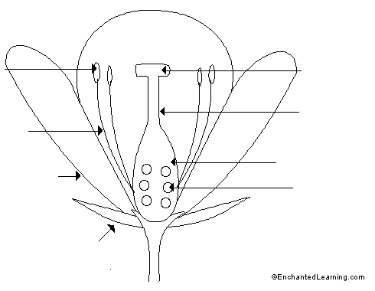
X
X
X
X
X
X
X
X
The male parts of the flower are the X and the X. Together they are called the X. This is where the male gamete called X is produced.

The female parts of the flower are the X, the X and the X. The female gamete called the X is produced here.

See how good you are using this site. Click on the “Parts of a Flower” section
http://www.bgfl.org/custom/resources_ftp/client_ftp/ks2/science/plants/index.htm

Do SciPad Pg 131, 133-135

Task 17
You will dissect a flower. Take a photo of the ovary with the ovules in place and paste it here.
Feel the base of the petals where they join the sepals. What does it feel like? X
This is because there is nectar produced here. What is nectar? X
The organ that produces nectar is the nectary. Add a label for the nectary on the diagram above.

Describe pollination and pollinators

Pollination is when the pollen moves from the anther of a flower to the stigma of another flower.
Pollen needs to get from one flower to another but plants can’t move around.The plant needs something else to carry the pollen for it.

Task 18
Watch this video:
http://www.youtube.com/watch?v=zy3r1zlC_IU
How does the pollen move from one flower to the other? X

What attracts the bee to the flower? X

What other things do you think the flower has that will attract the bee to the flower? (Hint: think why you like flowers) X

There is one other thing plants can use apart from animals (like insects) to carry their pollen. What is it? X

On the internet, find pictures of flowers that are pollinated by these two methods and paste them here and give them a label.

SciPad Pg 137-138

Task 19
Compare the two types of flowers and fill in the table
 | Method of pollination
 | x | x
Petals (size/colour/scent) | x | x
Size of anther | x | x
Size of stigma | x | x

Explain why flowers that aren’t animal pollinated need to have the structures you see.
X

Distinguish between pollination and fertilisation

Task 20
Watch this video:
http://www.youtube.com/watch?v=YqM6rgB_l_o
What is fertilisation? X
Explain why fertilisation happens after pollination. X

Write a paragraph explaining pollination and fertilisation. In you answer you should include:
- What pollination is and why do plants need to do it.
- The ways plants get pollinated.
- The differences in the flowers depending on the way they are pollinated.
- What fertilisation is and why it happens after pollination.
X

SciPad Pg 139

The importance of seeds

Describe the structure of a seed

Task 21
After fertilisation:
The ovule will develop into a X.
The ovary will develop into a X.

Use this video to help you label the seed diagram:
http://www.youtube.com/watch?v=G2gwDgIhxCw
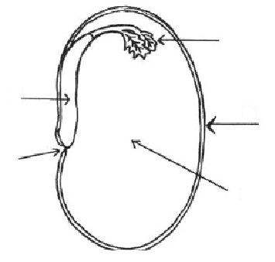
X
X
X
X
X
Write the function of the different parts:
Testa: X
Cotyledon: X
Micropyle: X
Radicle: X
Plumule: X
Together, the radicle and plumule are the baby plant. This is called the X

Task 22
You will dissect a seed. Take a photo and paste it in here.
Label the different parts.

Place a few drops of iodine onto the cotyledon. What happens? X What would you find in the cotyledon? X
Take a photo and paste it in here
Why would you find this substance in the cotyledon? X

SciPad Pg 140

Explain the need for seed dispersal

Task 23
What is seed dispersal? X

Use this animation to describe how the five most important methods of seed dispersal work and give an example for each method.
http://www.bgfl.org/custom/resources_ftp/client_ftp/ks2/science/plants/index.htm

Water: X and Example:
Edible fruit: X and Example:
Wind: X and Example:
Hooks: X and Example:
Explosion: X and Example:

It is important for the seed to be dispersed away from the parent plant to reduce the amount of competition. Name three things that individual plants would compete for:
X
X
X

SciPad Pg 141

Explain the requirements for germination of seeds

When the seed starts to grow into a new plant it is called germination.

Task 24
You will do an experiment over two weeks to observe the germination of some seeds. Take photos of your seeds and paste into the table.
Day 0 | Day 2 | Day 4 | Day 6
x | x | x | x
Day 8 | Day 10 | Day 12 | Day 14
x | x | x | x

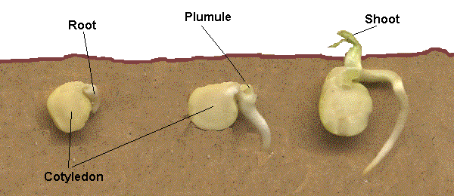

Task 25
Water is absorbed through the m and makes the seed swell. The t splits and the r emerges and grows downwards as it will become the root. The p then starts to grow upwards and will become the s. G is complete when the seedling produces leaves and can make its own food.

Why does the root form first? X

A seed is dormant and needs the right conditions to germinate (the WOW factors!). Name these factors and explain why the seed needs these conditions in order to germinate.
W
O
W

SciPad Pg 142-143

Task 26
Put seeds into four petri dishes:
Petri dish | Location | Watered? | Result after 8 days (paste photo)
1 | Incubator at 25º | Yes | x
2 | Incubator at 25º | No | x
3 | Fridge | Yes | x
4 | Fridge | No | x

Explain why the seeds on each petri dish did/did not germinate
1:
2:
3:
4:

Do seeds need light to germinate? X
How come the seed doesn’t need to do photosynthesis? X

The importance of plants to all life on our planet

Discuss the relationship between energy from the sun, the process of photosynthesis and the requirements for life

Plants use the energy of the sun to make food, which is then used by themselves and other organisms in the process of respiration, to give the energy for the processes of life.
If all plants died out, then all consumers (herbivores, omnivores and carnivores) would die as they would have no source of food.

Task 27
Write an essay on why plants are so important for life on Earth. Include the products of photosynthesis (food and oxygen) in your answer.

