LIVING WORLD – REPRODUCTION
Electronic Science LabBook
Designed by ALH

When you are required to put an answer in this booklet, the point at which you start typing is marked with a red X. Your typed answer should also appear in red. Delete the X leaving just your answer.
If you are required to paste or draw something, this is stated in BLUE. You can then photograph your work and paste it into this LabBook. In many experiments and investigations, you will be asked to photograph or video the experiment. You should insert these in the appropriate place in this LabBook.
When you are asked to look at a website for information to write an answer don’t just cut and paste the information in. Read the information and write an answer in YOUR OWN WORDS. You may wish to discuss your answer with your classmates and teacher first to make sure you understand it correctly.

For additional work (e.g. homework, revision) you will use the following books. You will be told which pages to use.
SciPad Book 2 Pg 190-193
Science World 10 textbook (written as SW10)

Learning outcomes for this topic

Describe the human life cycle
Task 1
List male and female changes that occur at puberty
Task 2
Task 3
Name the structures and explain the functions of the human male and female reproductive organs.
Task 4
Task 5
Define menstruation and explain the stages of the menstrual cycle
Task 6
Identify the stages of pregnancy
Task 7
Task 8
Explain how the new life is sustained during pregnancy
Task 9
Describe the main events during birth
Task 10

Describe the human life cycle
The human life cycle

Task 1
Name the biological processes in the human life cycle from the diagram below:
Adolescence, Adulthood, Childhood, Fertilisation, Meiosis, Mitosis
3

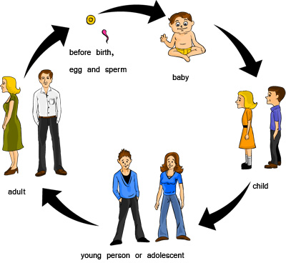
2

4
1

5
6

1 X
2 X
3 X
4 X
5 X
6 X

List male and female changes that occur at puberty
Watch the video on stages of puberty
http://www.youtube.com/watch?v=Rsj6dW6qKRc

Task 2
What is puberty?
X

The X organs mature to hormones released from the X.
Sexual organs start to release X and the body of the male and X start to change
Males release X
Females release X

What are primary sexual characteristics?
X
What are secondary sexual characteristics?
X
At what ages does puberty (usually) happen in girls and in boys?
X

Task 3
Puberty in girls
http://www.youtube.com/watch?v=j_mFJ2d0qxQ

List the changes in Females
X

Puberty in boys
http://www.youtube.com/watch?v=Yvw7QGytgNQ

List the changes in Males
X

List the changes that occur in both genders
X

Name the structures and explain the functions of the human male and female reproductive organs.
The Human Reproductive System

Task 4
Label the diagram of the male reproductive organs below, using the following terms
Bladder, Penis, Prostate gland, Scrotum, Sperm duct, Testis, Urethra
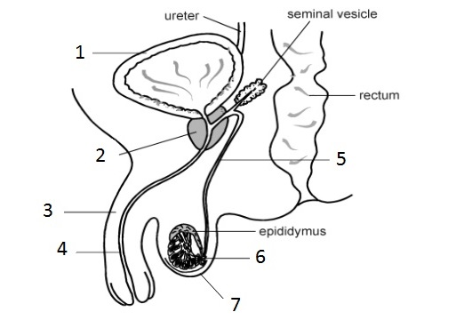
1 X
2 X
3 X
4 X
5 X
6 X
7 X

Explain the function of the following male reproduction organs:
Testis X
Scrotum X
Seminal vesicle X
Penis X

Outline the route taken from the testes by the sperm as it leaves the body:
X

Do SciPad Pg 190

Task 5
Label the diagram of the female reproductive organs below, using the following terms
Cervix, Ovary, Oviduct, Uterus, Vagina
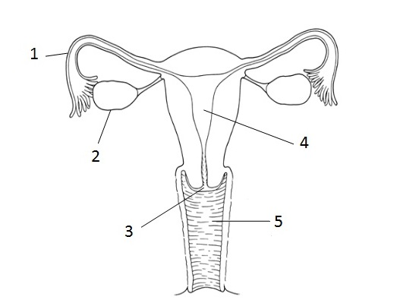
1 X
2 X
3 X
4 X
5 X

Name which female reproduction organ is being described below.
Sometimes called the womb – if an egg is fertilises it will implant in the wall of the uterus and develop into a foetus X
The opening or ‘neck’ of the uterus at the top of the vagina X
Connects the cervix to the outside of the body – the sperm is deposited here during sex X
The female sex cell – sometimes called the ‘egg’ X
After puberty, an egg or ovum is released from here once every 28 days or so X
Carries the ovum from the ovary to the uterus – the egg is fertilised here X

Do SciPad Pg 191

Define menstruation and explain the stages of the menstrual cycle
Menstruation and the menstrual cycle
http://www.youtube.com/watch?v=WGJsrGmWeKE

Task 6
Fill in the missing words in the statements below.
Stage 1
DAYS 1 TO 4
Bleeding starts as the lining of the X breaks down and passes out of the X.
This is known as X

Stage 2
DAYS 5 – 13
An X starts to mature and the lining of the X starts to build up again.

Stage 3
Around Day 12-14
An egg (ovum) is released from an X. This process is called X.

Stage 4
DAYS 15 – 28
The X wall stays thick waiting for a fertilised X.
If the egg is fertilised it will eventually X itself in the uterus wall.
If this does not happen, the cycle starts all over again.

Identify the stages of pregnancy

Early pregnancy – first week
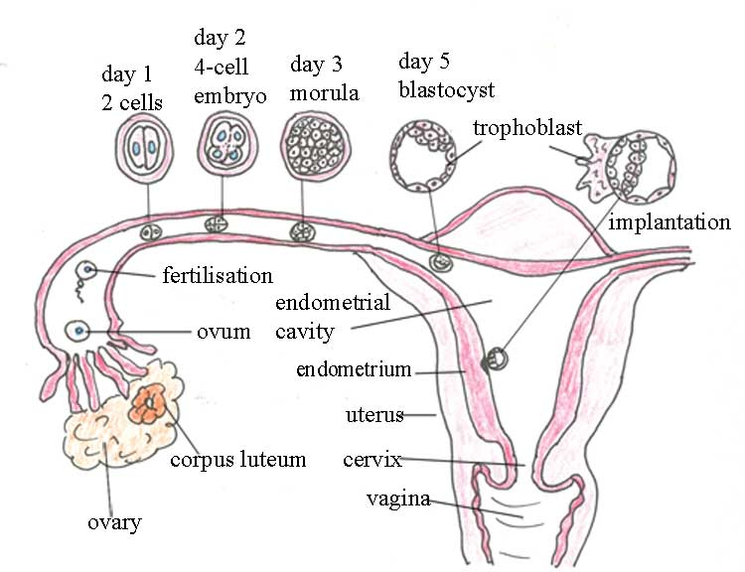

Task 7
Define the following terms:
Ovulation X
Fertilisation X
Implantation X

What method of cell division is used for the new life to develop? X
Explain why the embryo undergoes implantation.

Do SciPad Pg 192

Task 8
Download and read the pdf on the stages of pregnancy from the WGHS Junior Science site. Answer the following questions.
How long does pregnancy usually last? X
Explain the difference between a zygote, an embryo and a foetus
X

Do SciPad Pg 193

Explain how the new life is sustained during pregnancy

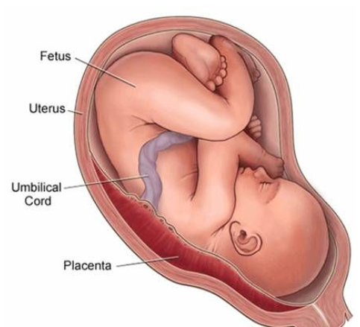
During pregnancy, the developing foetus is sustained by a placenta which exchanges substances between mother's blood and foetus' blood without the bloods mixing.

Both oxygen & food and transferred from the mother to foetus, providing the foetus with enough nutrients to survive. Carbon dioxide (CO₂) & wastes are transferred from the foetus to mother. This is because the foetus cannot get rid of these wastes on its own, so it passes them on to the mother who gets rid of them.

Parts of a developing foetus include the amniotic fluid which controls temperature and helps with shock absorption, the umbilical cord which connects the foetus to the placenta.

The placenta is a ‘pancake’ shaped structure that is full of blood vessels. This system is called the ‘life support system’ as it acts like a life support machine in hospitals which contain cords that pass nutrients to the patient and help get rid of their wastes. During pregnancy, the umbilical cord and placenta pass nutrients, and wastes between the mother and the baby, keeping it alive and healthy so it can grow into a baby.

During pregnancy, if the mother takes drugs and alcohol, the foetus is at risk of developing foetal alcohol syndrome. This is because when drugs and alcohol are taken, they enter the blood stream, which can become an issue considering blood is how the foetus gets its food and nutrients. The harmful substances in the drugs and alcohol can be passed from the mother to the foetus via the umbilical cord.

Task 9
Describe the structure and function of the following structures:
Placenta X
Umbilical cord X
Amniotic sac X

What substance is not exchanged? X

What is the role of the Umbilical Cord? X

What substances pass from the mother to the foetus? X
What substances pass from the foetus to the mother? X

What mechanism does the placenta use to exchange gases? X

Why is the baby in a sac of fluid? X

Explain what is meant by the term ‘life support system. In your answer, discuss why you think the placenta and umbilical cord act like a life support machine for a baby during pregnancy.
X

Describe the main events during birth

Three stages of labour/birth
http://www.youtube.com/watch?v=BgZ5z6RB06c

Task 10
Describe the 3 stages of labour (birth).
Stage 1
X

Stage 2
X

Stage 3
X

