**MATERIAL WORLD – TYPES OF REACTIONS**

**Electronic Science LabBook**

***Designed by HMG***

When you are required to put an answer in this booklet, the point at which you start typing is marked with a **red X.** Your typed answer should also appear in **red**. Delete the **X** leaving just your answer.

If you are required to paste or draw something, this is stated in **BLUE.** You can then photograph your work and paste it into this LabBook. In many experiments and investigations, you will be asked to photograph or video the experiment. You should insert these in the appropriate place in this LabBook.

When you are asked to look at a website for information to write an answer don’t just cut and paste the information in. Read the information and write an answer in **YOUR OWN WORDS**. You may wish to discuss your answer with your classmates and teacher first to make sure you understand it correctly.

For additional work (e.g. homework, revision) you will use the following books. You will be told which pages to use. SciPad –

Science World 10 textbook

**Learning outcomes for this topic**

Review of Year 9 work

* Atoms and their structure including bulls eye diagrams.
* Elements, Compounds and Mixtures.
* The periodic table is a way of classifying elements according to their atomic number.
* Difference between physical and chemical changes, and how to recognise them.
* Task 1
* Task 2

The Periodic Table, formation of ions and ionic compounds

* Understand the arrangement of the periodic table
* Task 3
* Task 4
* Draw bullseye diagrams of atoms and ions
* State the electronic configuration of atoms and ions
* Task 5
* Task 6
* Explain the formation of cations by losing electrons
* Explain the formation of anions by gaining electrons
* Describe ionic compound formation
* Write ionic formulae using ion table
* Task 7
* Explain the difference between ionic compounds and molecules
* Classify a list of substances as either ionic compounds or molecular substances
* Task 8

Physical and Chemical changes and Types of Reactions

* Define a physical and a chemical change
* Recognise when a physical and a chemical change occur
* Task 9

Classify decomposition, precipitation/exchange and combustion reactions, based on observations

Use word and formula equations to represent specified chemical reactions

* Task 10
* Task 11

# Review of Year 9 work

## Atoms and their structure including bulls eye diagrams

## Elements, Compounds and Mixtures.

## The periodic table is a way of classifying elements according to their atomic number.

## Difference between physical and chemical changes, and how to recognise them.

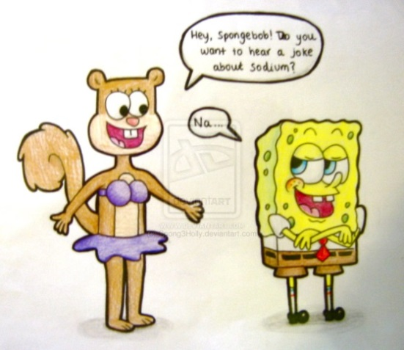

Watch the powerpoint called ‘*Review of Year 9 work*” in class, your

teacher will put it on Edmodo or Blendspace for your reference as well.

Write a summary of information from the powerpoint

X

### TASK ONE

Experiment:

1. Heat a piece of chocolate in a tablespoon over a beaker of hot water.

2. Boil an egg in a beaker of hot water.

Paste photographs here to show what happens

Which change is a physical change? X

Explain your answer: X

Which change is a physical change? X

Explain your answer: X

### TASK TWO

Complete the following table to explain the meaning of the words:

atom - X

atomic number- X

mass number - X

element - X

compound – X

mixture - X

periodic table - X

physical change - X

chemical change - X

# The Periodic Table, formation of ions and ionic compounds

## [https://encrypted-tbn3.gstatic.com/images?q=tbn:ANd9GcQTFWq7iuaAANW4bz2GKL6CPDvx8y-NkfQ6r6v-MVuc0gWXXVschA](http://www.google.co.nz/imgres?start=142&biw=1058&bih=473&tbm=isch&tbnid=EWODJFYhGVncPM:&imgrefurl=http://www.stuff.co.nz/nelson-mail/entertainment/movies/8906186/Mixed-bag-at-the-movies&docid=DE-vQLRpqmy8CM&imgurl=http://static2.stuff.co.nz/1373503915/359/8906359.jpg&w=360&h=433&ei=zusaU4LoO4iIogTRs4LYAQ&zoom=1&ved=0CJ8BEIQcMDI4ZA&iact=rc&dur=940&page=11&ndsp=14)Understand the arrangement of the periodic table

TASK THREE  
The columns of the periodic table are called X and tell us X

The rows of the periodic table are called X and tell us X

Paste a periodic table here, preferably one that shows the group numbers

### TASK FOUR

Visit some sites showing information about the periodic table (possible sites to visit given below)

<http://www.chemicalelements.com/>

<http://www.rsc.org/periodic-table/?gclid=CICP_8Kygr0CFQJxvAodFwsA5A>

http://www.learner.org/interactives/periodic/

Which group and period would you put the atoms with the following electron arrangements:

Unknown atom (a): 2,2 group X period X

Unknown atom (b): 2,8,7 group X period X

Unknown atom (c): 2,8,1 group X period X

Unknown atom (d): 2,6 group X period X

Unknown atom (e): 2,8,8,1 group X period X

For Experts: Find out about isotopes. Be prepared to explain it to the class next period. X

## [http://www.spot.ph/files/2013/07/1372920499-WL-Minion.jpg](http://www.google.co.nz/url?sa=i&rct=j&q=&esrc=s&frm=1&source=images&cd=&cad=rja&uact=8&docid=9qFmHQbTFSiCRM&tbnid=CU0S1UpSEzRD_M:&ved=0CAUQjRw&url=http://www.spot.ph/newsfeatures/53863/winners-losers-of-the-week-the-minions-carlo-j-caparas-others&ei=x-waU-mgFqv1iQeD5YCYDQ&psig=AFQjCNF-3VVb5ZjlCy_hEK0sLq8h-kaZMw&ust=1394359547052334)Explain the formation of cations by losing electrons

## Explain the formation of anions by gaining electrons

## Draw bullseye diagrams of atoms and ions

## State the electronic configuration of atoms and ions

One of the driving forces in chemistry is for an atom to obtain a full valence (outer) energy level, so an atom which does not yet have this arrangement, will tend to lose, gain or share electrons in order to obtain a full valence level and therefore become more X. Positive ions (called X) are formed when atoms X electrons. Negative ions (called X) are formed when atoms X electrons.

<http://www.youtube.com/watch?v=Bfg9pq3Whmw>

<http://www.youtube.com/watch?v=900dXBWgx3Y>

### TASK FIVE

Complete the following: (the first example has been done for you)

sodium atom (Na): atomic number = 11 and mass number = 23

number of protons = 11

number of neutrons = 12

number of electrons = 11

electronic arrangement = 2,8,1

sodium ion (Na+): atomic number = 11 and mass number = 23

number of protons = 11

number of neutrons = 12

number of electrons = 10

electronic arrangement = 2,8

magnesium atom (Mg): atomic number = 12 and mass number = 24

number of protons = X

number of neutrons = X

number of electrons = X

electronic arrangement = X

magnesium ion (Mg2+): atomic number = 12 and mass number = 24

number of protons = X

number of neutrons = X

number of electrons = X

electronic arrangement = X

sulfur atom (S): atomic number = 16 and mass number =32

number of protons = X

[](http://www.google.co.nz/url?sa=i&rct=j&q=&esrc=s&frm=1&source=images&cd=&cad=rja&uact=8&docid=9qFmHQbTFSiCRM&tbnid=CU0S1UpSEzRD_M:&ved=0CAUQjRw&url=http://www.albireo.net/threads/35167/&ei=7ewaU6C3E-6UiAeO3YDYAg&psig=AFQjCNF-3VVb5ZjlCy_hEK0sLq8h-kaZMw&ust=1394359547052334)number of neutrons = X

number of electrons = X

electronic arrangement = X

sulfide ion (S2-): atomic number = 16 and mass number = 32

number of protons = X

number of neutrons = X

number of electrons = X

electronic arrangement = X

chlorine atom (Cl): atomic number = 17 and mass number = 35

number of protons = X

number of neutrons = X

number of electrons = X

eectronic arrangement = X

chloride ion (Cl-): atomic number = 17 and mass number = 35

number of protons = X

number of neutrons = X

number of electrons = X

electronic arrangement = X

The process of ion formation can be represented as follows:

The sodium atom loses 1 electron to form a positive sodium ion. Na: 2,8,1 🡪 Na+: 2,8 + 1e

The sodium ion has a +1 charge because it has 11 protons(+11) and 10 electrons(-10), so has one more proton than electron.

The chlorine atom gains 1 electron to form a negative chloride ion. Cl: 2,8,7 + 1e 🡪 Cl-: 2,8,8

The chloride ion has a -1 charge because it has 17 protons(+17) and 18 electrons(-18), so has one more electron than proton.

[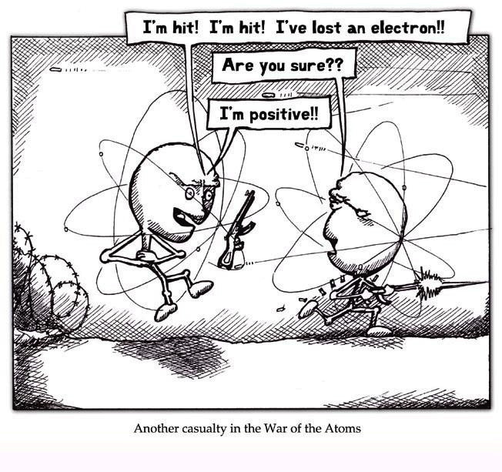](http://eveecology.files.wordpress.com/2012/10/5494173_700b1.jpeg)

TASK SIX:

Explain how a magnesium atom forms the magnesium ion. Then write an equation to represent the process. ( as shown above)

X

Explain how a fluorine atom forms the fluoride ion. Then write an equation to represent the process.

X

Explain how a calcium atom forms the calcium ion. Then write an equation to represent the process.

X

Explain how an aluminium atom forms the aluminium ion. Then write an equation to represent the process.

X

Explain how a sulfur atom forms the sulfide ion. Then write an equation to represent the process.

X

Finally:

Develop with a rule (or rules) that links the group number to the charge on the ion formed.

X

## Describe ionic compound formation

## Write ionic formulae using ion table

Once we have positive ions and negative ions, the zillions of oppositely charged ions attract each other and are held together in a giant 3-d crystal lattice by these electrostatic forces of attraction which are called ionic bonds. The ratio of positively charged ions to negatively charged ions is the ionic formula of the compound e.g. sodium chloride = NaCl

[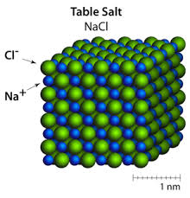](http://www.google.co.nz/imgres?start=150&sa=X&biw=1058&bih=473&tbm=isch&tbnid=eDOZMj4B4s88zM:&imgrefurl=http://www.atomsinmotion.com/book/chapter4/salts&docid=ONtKVcrtOK-BzM&imgurl=http://www.atomsinmotion.com/book/chapter4/rockSalt.png&w=300&h=313&ei=1eEaU6-NO87aoASRx4LQDg&zoom=1&ved=0CMABEIQcMD04ZA&iact=rc&dur=1875&page=13&ndsp=14)

### TASK SEVEN

Youtube - about writing ionic formulae using only monatomic ions: [http:/ /www.youtube.com/watch?v=URc75hoKGLY](http://www.youtube.com/watch?v=URc75hoKGLY)

Youtube - about writing ionic formula containing polyatomic ions: <http://www.youtube.com/watch?v=p9iQ5Qn42DM>

Youtube - more practice with writing ionic formulae:

<http://www.youtube.com/watch?v=X_LVANMpJ0c>

[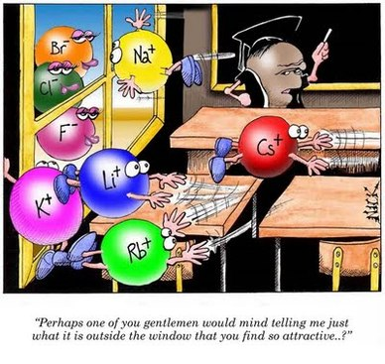](http://covarrubiaschemistryresource.weebly.com/uploads/1/9/4/6/19464399/2909565_orig.jpg?388)

[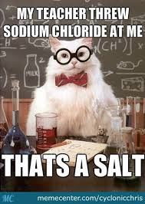](http://www.google.co.nz/url?sa=i&rct=j&q=&esrc=s&frm=1&source=images&cd=&cad=rja&uact=8&docid=f7Me245s19452M&tbnid=5UTQj-8rGYvCaM:&ved=0CAUQjRw&url=http://www.memecenter.com/fun/2530679/chemistry-cat-strikes-again&ei=quIaU-uSE-iOige524DoBA&bvm=bv.62578216,d.cGU&psig=AFQjCNF5kTKhmV6vf7shMMQMn83eKHcG3A&ust=1394357218993351)

The following two websites are great for helping to write formulae:

Interactive ionic compounds: <http://www.learner.org/interactives/periodic/index.html>

Interactive using scales: <http://www.chemfiles.com/flash/formulas.html>

## Explain the difference between ionic compounds and molecules

## Classify a list of substances as either ionic compounds or molecular substances

When we have bonding between metals and non-metals, we result in an X compound, which is made out of X and X

When we have bonding between non-metals and non-metals, we result in a X compound, which is made out of individual X

### TASK EIGHT

Make a table, putting all the ionic substances in one column and all the molecular substances in another column. Use google to search for diagrams representing each substance, to place next to the name.

sodium chloride (NaCl) water (H2O) ammonia (NH3) magnesium oxide (MgO)

glucose (C6H12O6) Silver fluoride (AgF) methane (CH4) ethanol (CH3CH2OH)

# Physical and chemical changes and Types of Reactions

## Define a physical and a chemical change

## Recognise when a physical and a chemical change occurs

[](http://www.google.co.nz/url?sa=i&rct=j&q=&esrc=s&frm=1&source=images&cd=&cad=rja&uact=8&docid=9qFmHQbTFSiCRM&tbnid=CU0S1UpSEzRD_M:&ved=0CAUQjRw&url=http://www.wallpaperswala.com/despicable-me-minions/&ei=KO0aU9-4L4XniAeQi4A4&psig=AFQjCNF-3VVb5ZjlCy_hEK0sLq8h-kaZMw&ust=1394359547052334)[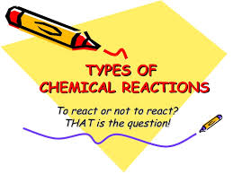](http://www.google.co.nz/imgres?biw=1058&bih=473&tbm=isch&tbnid=38u-kgwbkKr86M:&imgrefurl=http://www.slideshare.net/lauralici/chemical-reactions-1196945876279030-3&docid=aWKMnl8Ro5sYdM&imgurl=http://cdn.slidesharecdn.com/ss_thumbnails/chemical-reactions-1196945876279030-3-091221214927-phpapp02-thumbnail-4.jpg?cb%3D1261453876&w=768&h=576&ei=XegaU6vGL4fooATWzoCYDQ&zoom=1&ved=0CNwBEIQcMCw&iact=rc&dur=4196&page=4&start=38&ndsp=14)

### TASK NINE

Definition of physical change: X

Explain how we would know a change that we observe is a physical change: X

Definition of chemical change: X

Explain how we would know a change that we observe is a chemical change: X

Classwork: Take before and after photographs of each of the following three chemical changes, then write word and formula equations for each of them (you did these reactions in Year 9)

Burning a piece of magnesium ribbon

Adding a piece of magnesium ribbon to hydrochloric acid

[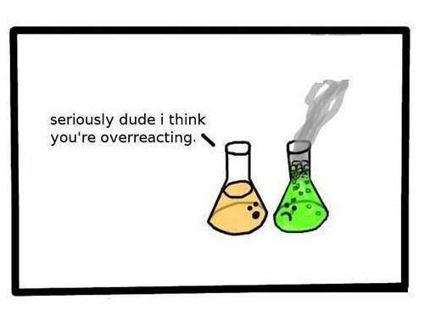](http://static.fjcdn.com/pictures/Chemistry+Jokes+are+fun_02055e_4601268.jpg)Heating copper carbonate powder in a boiling tube

HOMEWORK: At home Watch the Clickview in Science : “Chemical Reactions - Material World Series”

## Classify decomposition, precipitation/exchange and combustion reactions, based on observations

## Use word and formula equations to represent specified chemical reactions

There are millions and millions of different reactions. To help us make sense of them, we can classify them into different types (in much the same way that we classify all the millions of different animals into different types, such as dogs, cats, birds, fish etc)

In year 10, we will be looking at a few types of reactions. In this section of work we will look at **decomposition reactions**, **precipitation/exchange reactions** and **combustion reaction**s.

### TASK TEN – Experiments

Decomposition Reactions

One reactant breaks down into two or more products.

Youtube lesson : <http://www.youtube.com/watch?v=bQJvbmHD1Lg>

C:\Users\mhamling\AppData\Local\Microsoft\Windows\Temporary Internet Files\Content.IE5\9606T70J\MC900445120[1].wmfC:\Users\mhamling\AppData\Local\Microsoft\Windows\Temporary Internet Files\Content.IE5\T3H261XX\MC900390784[1].wmf

C:\Users\mhamling\AppData\Local\Microsoft\Windows\Temporary Internet Files\Content.IE5\9606T70J\MC900445120[1].wmfC:\Users\mhamling\AppData\Local\Microsoft\Windows\Temporary Internet Files\Content.IE5\T3H261XX\MC900390784[1].wmf

Take photographs of two different decomposition reactions in class. Write word and fomula equations for each. X

Precipitation/Exchange Reactions (some websites and texts call it double displacement)

When two solutions are mixed to produce a solid product. The ions swop partners and one of the products is an insoluble substance.

C:\Users\mhamling\AppData\Local\Microsoft\Windows\Temporary Internet Files\Content.IE5\02U9Q1WH\MC900438237[1].wmfC:\Users\mhamling\AppData\Local\Microsoft\Windows\Temporary Internet Files\Content.IE5\AD6ZRQRD\MC900438233[1].wmfC:\Users\mhamling\AppData\Local\Microsoft\Windows\Temporary Internet Files\Content.IE5\02U9Q1WH\MC900438237[1].wmfC:\Users\mhamling\AppData\Local\Microsoft\Windows\Temporary Internet Files\Content.IE5\79WFX5RL\MC900438235[1].wmfC:\Users\mhamling\AppData\Local\Microsoft\Windows\Temporary Internet Files\Content.IE5\79WFX5RL\MC900438235[1].wmf

C:\Users\mhamling\AppData\Local\Microsoft\Windows\Temporary Internet Files\Content.IE5\AD6ZRQRD\MC900438233[1].wmfC:\Users\mhamling\AppData\Local\Microsoft\Windows\Temporary Internet Files\Content.IE5\EKABHGCH\MC900438239[1].wmfC:\Users\mhamling\AppData\Local\Microsoft\Windows\Temporary Internet Files\Content.IE5\EKABHGCH\MC900438239[1].wmf

Take photographs of four different precipitation/exchange reactions in class. Write word and fomula equations for each. X

Combustion Reactions

A substance reacts with oxygen, producing a lot of energy.

[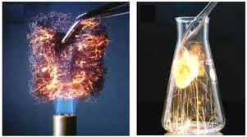](http://www.google.co.nz/imgres?biw=732&bih=680&tbm=isch&tbnid=cUmavwmt4LsD4M:&imgrefurl=http://www.bcscience10.com/pgs/quiz_section6.2.htm&docid=3Mrknzdo-Un3dM&imgurl=http://www.bcscience10.com/images/0_quiz-6.2-05.jpg&w=450&h=251&ei=gegbU_f7EsKQkwWnwIC4Bw&zoom=1&ved=0CIMBEIQcMBE&iact=rc&dur=835&page=2&start=11&ndsp=13)

[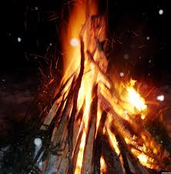](http://www.google.co.nz/imgres?start=192&biw=732&bih=680&tbm=isch&tbnid=Q0N89DWStsC95M:&imgrefurl=http://www.pxleyes.com/photography-picture/4dc8db6d40288/Camp-Fire.html&docid=BT693AwgxGhxqM&imgurl=http://www.pxleyes.com/images/contests/fire-le/fullsize/Camp-fire-4dc38d722f3be_hires.jpg&w=2064&h=2112&ei=2OkbU6OoMoWtlAXCwYBg&zoom=1&ved=0CKkCEIQcMGA4ZA&iact=rc&dur=2441&page=15&ndsp=14)[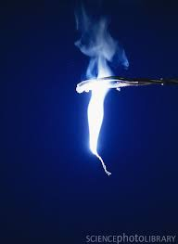](http://www.google.co.nz/imgres?biw=732&bih=680&tbm=isch&tbnid=MFA_62glhpDgDM:&imgrefurl=http://ong-sim-hao.blogspot.com/&docid=-FF4TzhJZ9fegM&imgurl=http://4.bp.blogspot.com/-0cTaYyW0ylw/TlxpYWJ8SrI/AAAAAAAAAB0/Cm67Ju93H5o/s1600/A5100208-Magnesium_ribbon_burning-SPL.jpg&w=387&h=530&ei=WOkbU-O0D82XkwW3qoGYDQ&zoom=1&ved=0CJcBEIQcMBU&iact=rc&dur=3566&page=2&start=12&ndsp=16)[](http://www.google.co.nz/url?sa=i&rct=j&q=&esrc=s&frm=1&source=images&cd=&cad=rja&uact=8&docid=YeXy3H_-TfigPM&tbnid=wMapMgydTFAoOM:&ved=0CAUQjRw&url=http://www.education.com/science-fair/article/burning-candle-chemical-reactions/&ei=5OgbU5eyMYmMkwWYmYHQDQ&bvm=bv.62578216,d.dGI&psig=AFQjCNGGHWqMKT_4fH21UmsRlRCttJ2A4w&ust=1394424321710583)

Take photographs of two different combustion reactions in class. Write word and fomula equations for each. X

### TASK ELEVEN

Make a poster about what you have learned in this Chemistry Topic. Use pictures, word bubbles to create an attractive an informative presentation.

EXTRA FOR EXPERTS: BALANCING EQUATIONS

Task : Go to the following website and practice balancing equations

<http://funbasedlearning.com/chemistry/chemBalancer/default.htm>