Year 9 Science
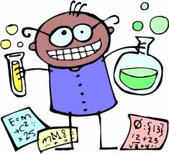
Exam Revision
Booklet
Name: _________________ Form: _______ Teacher: _______
1 | BEING SCIENTIFIC  Next to the lab equipment below, draw each piece of equipment and state what it is used for:  - Test tube  - Beaker  - Conical flask  - Test tube scissors  - Bunsen burner  - Clamp stand  - Thermometer  - Funnel  - Test tube rack  - Measuring cylinder  - Evaporating basin
2 | 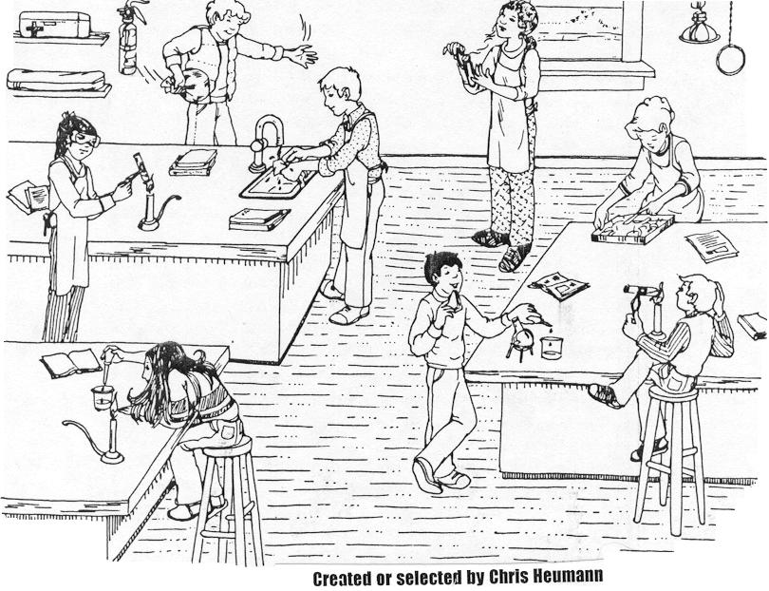  Use the following picture to identify 5 situations where students aren’t following the lab safety rules. For each situation, describe what the student is doing incorrectly and explain what may happen as a consequence.
3 | Write down (list) the correct procedure for lighting a Bunsen burner. Include the use of the orange and blue flame and explain how they are produced.
4 | Label the drawing correctly.  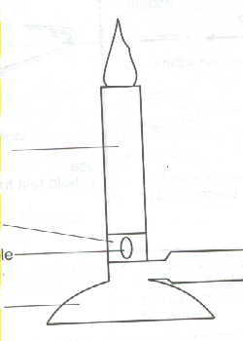
5 | Write down (list) 5 laboratory safety rules as well as the reason they are necessary.
6 | List the 2 main types of Bunsen burner flames and say what each is used for.
7 | Identify each of the following hazard symbols.  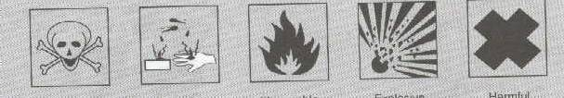
8 | Design an experiment to show which temperature of water dissolves salt faster: cold or hot? Make sure it is a fair test with a hypothesis, independent varible, controlled variables and a dependent variable etc.
9 | 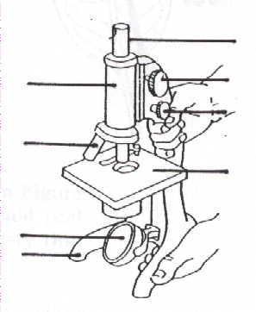  Label the drawing and explain the function of each part of the microscope.
10 | Design an experiment to determine whether sunlight has an effect upon the germination of a seed. How would you ensure that this is a fair test? List all the factors that you should keep constant.
11 | Define the following terms:  Hypothesis Variable Independent Variable Controlled/Fixed Variable Dependent Variable
12 | Draw the apparatus set up needed for the following experiments:  - Boiling 100mL of water  - Separating sand from water  - Boiling 300mL of water
13 | The following readings were recorded by measuring distance a cyclist travelled within a one-hour period. Use the acronym TELLX to plot your results.  i. Identify the dependent variable. ii. How far did she ride in 25 minutes – show on your graph.  Time (mins) Distance (kilometres)  0 0  10 3  20 6  30 10  40 12  50 14  60 17
14 | Describe the term ‘fair testing’.
15 | Describe the difference between continuous and discontinuous data and explain what type of graph you would use for each and why.
16 | CLASSFICATION  Name the 8 requirements needed for something to be considered a ‘living thing’.
17 | Name the five kingdoms that all living things are classified into.
18 | Write down the characteristics of mammals.
19 | Create different classification keys for the following groups of things:  - Starfish, seahorse, fish, shark, dolphin  - Flax bush, palm tree, grass, daisy, pohutakawa
20 | List the life processes in MRS C GREN and give an example of each.
21 | Define the term ‘living’ and give an example of something living.
22 | Define the term ‘non-living’ and give an example of something non-living.
23 | Define the term ‘dead’ and give an example of something dead.
24 | Discuss the difference between living, non-living and dead.
25 | List two reasons classification keys are useful for Scientists.
26 | CELLS  List the differences between plant cells and animal cells.
27 | List the similarities between plant cells and animal cells.
28 | Name the structure responsible for the shape of a plant cell.
29 | Describe the difference in shape between a plant cell and an animal cell.
30 | List all of the organelles (parts of a cell – plant and animal) and list their functions as well.
31 | Label the diagram of an animal cell and state the function of each.  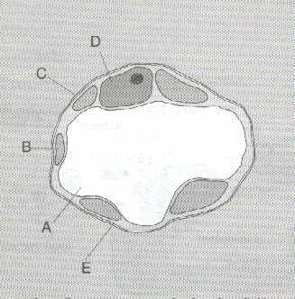
32 | Draw a plant cell and label it (use scientific drawing rules).
33 | Draw a animal cell and label it(use scientific drawing rules).
34 | Living organisms are built out of cells. Cells are assembled into simple structures, which are in turn assembled into more complex structures. Put the following structures into the correct order.  Organ tissue cells organism organ system
35 | List 5 organelles of a cell (any cell) and describe their function.
36 | ENERGY  Define Energy.
37 | What is the symbol for Energy?
38 | What is Energy measured in?
39 | What is the unit of measurement?
40 | Describe the law of conservation of energy.
41 | What type/form of energy is commonly produced as ‘waste energy’?
42 | Distinguish between Active Energy and Potential Energy. Give an example of each.
43 | Explain how heat is transferred via CONDUCTION.
44 | Find 3 examples of CONDUCTION and describe them.
45 | Name the different types/forms of Energy.
46 | Next to the forms of Energy you named in 45), write whether they are active or potential energy
47 | Explain how heat is transferred via CONVECTION.
48 | Find 3 examples of CONVECTION and describe them.
49 | Explain how heat is transferred via RADIATION.
50 | Find 3 examples of RADIATION and describe them.
51 | Describe the term ‘energy transfer’.
52 | Draw an energy chain for the following pictures:
53 | Describe the link between heat energy and kinetic energy.
54 | Describe the term ‘energy transformation’.
55 | Choose 10 objects in everyday life and write energy chains for those objects.  eg A light bulb Electrical energy Light energy + Heat energy
56 | Name 2 different forms of energy found in a kitchen whizz.
57 | Name 3 different forms of energy found in a car.
58 | Name 2 different forms of energy in a television.
59 | Describe the direction that heat energy flows in.
60 | 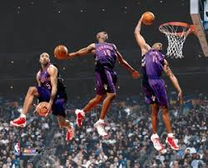  Explain in detail, the energy transformations that are taking place in the picture below. You must mention the energy changes, as well as what it is about the picture that tells you what type of energy is occuring.
61 | MATTER  If you put a balloon on top of a conical flask and heat the flask, what do you think would happen? Explain why, using the particle theory.
62 | A piece of foam has a volume of 50mL and has a mass of 10grams. Calculate the density of the piece of foam. Make sure you show your working.
63 | What is the calculation for density? Name the unit(s) of measurement for density?
64 | Explain the relationship between density and floating. Include an example in your answer.
65 | Explain the relationship between density and sinking. Include an example in your answer.
66 | When a can is heated and placed in cold water it implodes (the walls of the can cave in). Explain what happened, using the particle theory.
67 | Write definitions for the following terms. (Make sure you use good scientific definitions that include key words – you may need to use your notes, textbook or scipad for help). You may want to make two columns with the headings ‘key word’ and ‘definitions’.  Matter Solid Liquid Gas Evaporating Boiling  Freezing Solidifying Density Particle Theory Sublimation Condensing Volume Mass Diffusion Expansion  Contraction Cooling Heating Kinetic Energy
68 | Draw 3 separate diagrams to show the particle arrangements in solids, liquids and gases.
69 | Draw a labelled diagram to show the changes in the states of matter.
70 | Compare compressibility of solids, liquids and gases.
71 | Compare the flow of solids, liquids and gases.
72 | Compare the shape of solids, liquids and gases.
73 | Compare the movement of solids, liquids and gases.
74 | A metal ball was unable to fit through a hoop. The hoop was heated and then the ball was able to fit through the hoop. Explain, using scientific ideas, how the ball could now fit through the hoop when it initially couldn’t
75 | Railway track have gaps in them. Explain why you think they have gaps in them. Make sure you include scientific ideas and relate it back to the railway tracks. Be thorough in your explanation.
76 | Thermometers are excellent examples of expansion and contraction. Explain, using definitions of expansion and contraction, how thermometers work.
77 | On flammable products there are labels and warning signs to keep the product away from fire or heat. Explain why you think that is important, using scientific reasoning. Discuss some of the consequences that could occur.
78 | Does temperature affect the rate of diffusion? If so, explain how?
79 | If perfume was sprayed at one end of the room, would you be able to smell it at the other end of the room straight away? Explain your answer.
80 | Draw diagrams to show the arrangement of particles in liquids, gases and solids.
81 | Complete this diagram by showing the changes of state.  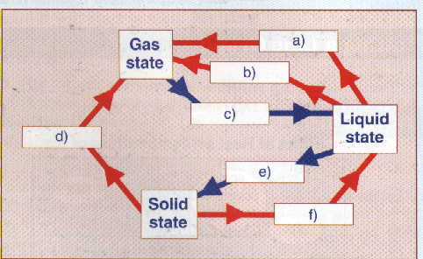
82 | ATOMS AND CHEMICAL REACTIONS  Draw a table to show the atomic number, mass number, symbol and name of the first 20 elements of the periodic table.
83 | From the first 20 elements, list the metals and non-metals in separate columns with two headings.
84 | 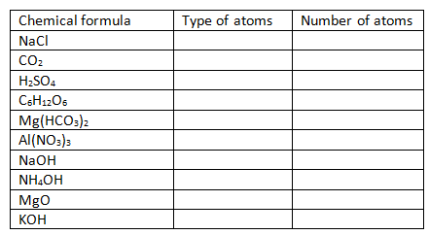  Complete the table into your science books:
85 | Draw a labelled diagram of an atom. Make sure you include the following structures:  Nucleus, Electron Shell, Electron, Proton, Neutron,
86 | Describe the term ‘atom’.
87 | Distinguish between atoms, molecules, elements, compounds and mixtures using both definitions and diagrams. Some things you should include in your answer:  How are they different from each other? Are there any similarities? Are there any examples that you can think of for each one?
88 | Complete the following table for each of the first 20 elements:
89 | Distinguish between physical and chemical change when chemical reactions occur. In your answer include definitions for both chemical and physical change and a description of how they differ from each other.
90 | Give a list of possible evidence to show that a chemical reaction may have occurred.
91 | 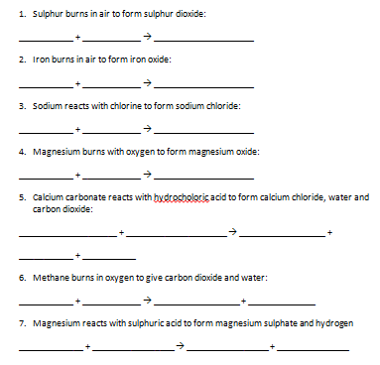  Copy the following information into your science books and write the word equations:
92 | For all of the equations in question 12, list the products for each reaction.
93 | For all of the equations in question 12, list the reactants for each reaction.
94 | Describe how you would test for Carbon Dioxide. Include the reason you would know that it was CO₂
95 | Name the 3 common gases produced in chemical reactions and give their formulae.
96 | Describe the three tests used to figure out which gas is produced in a reaction.
97 | Describe how you would test for Carbon Dioxide. Include the reason you would know that it was CO₂
98 | The following elements are not in the first 20 but are important to learn. List them in a table and learn their name and symbol (don’t worry about their atomic or mass no).  Iron, Copper, Zinc, Silver, Bromine, Iodine, Gold, Mercury, Lead, Platinum, Uranium.
99 | Write how many of each different atom there is in each of the following formulae:  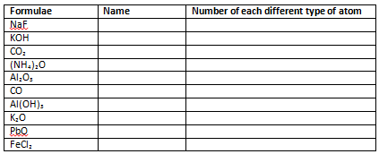
100 | Explain how you calculate the number of protons, neutrons and electron in an atom.
101 | The following are a list of reactions. You must read each one, write it into your science books and indicate whether it is a chemical or physical change that is occurring in each reaction:  Crumpling a piece of paper, Burning wood, Melting ice cubes, Dissolving sugar in water, Crushing a can, Rusting of Iron, Boiling water, Breaking a glass, Cooking an egg, Shredding paper, Baking a cake, Adding food colouring to water, Cooking toast.
102 | LIGHT AND SOUND  Describe Reflection.
103 | State the law of Reflection.
104 | Describe Refraction.
105 | State the law of Refraction.
106 | Describe what is meant by the term ‘angle of incidence’.
107 | Describe what is meant by the term ‘angle of reflection’.
108 | Complete a diagram to show how 3 beams of light are refracted through a concave lens.
109 | Complete a diagram to show how 3 beams of light are reflected off a concave mirror.
110 | Describe whether the light rays converge or diverge in a concave mirror. Explain why.
111 | Label the diagram of the eye:  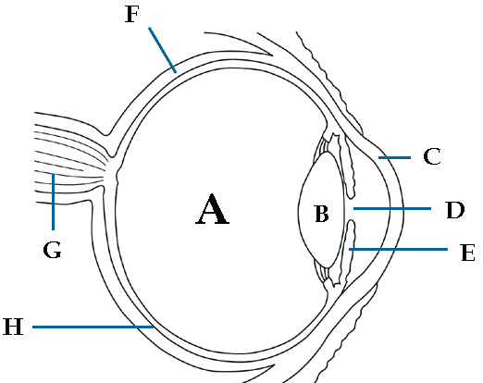
112 | State the function of each labelled structure in question 111.
113 | Complete a diagram to show how 3 beams of light are refracted through a convex lens.
114 | Complete a diagram to show how 3 beams of light are reflected off a convex mirror.
115 | Explain why shadows are formed.
116 | 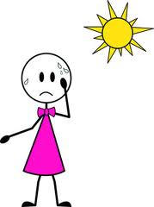  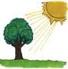  On the diagrams below, draw a line to show the shadow that would be formed:
117 | Describe the terms ‘opaque’, ‘translucent’ and ‘transparent’.
118 | Explain how rainbows are formed, using scientific terms.
119 | Name the 3 primary colours.
120 | Draw a diagram to show the possible colours produced when mixing light.
121 | Describe the nature of white light.
122 | Name the scientific term for colours being split up.
123 | Name the seven colours of the rainbow, in order.
124 | A green light is shone onto a blue book. Describe what you would observe and explain why.
125 | A yellow light is shone onto a red apple. Describe what you would observe and explain why.
126 | A blue light is shone onto a blue folder. Describe what you would observe and explain why.
127 | A white light is shone onto a yellow pen. Describe what you would observe and explain why.
128 | A red light is shone onto a green ring. Describe what you would observe and explain why.
129 | List the structures in the ear in the order that sound passes through them.
130 | Explain how your ear responds to sounds.
131 | Listening to loud sounds for a long time can cause damage to your ears. How?
132 | Describe what would happen if the words were signs that were placed in front of a mirror. Draw what you would see.  SCIENCE EMERGENCY LABORATORY DIAL 111 HOSPITAL CAUTION
133 | Label this diagram.  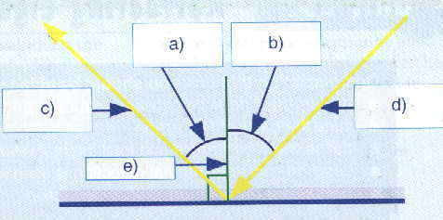
134 | EARTH SYSTEMS  If a baby that had a mass of 8kg on earth went to the moon, describe where he would weigh more. Use calculations to prove your answer. Gravity on the moon=3.4 Gravity on earth=9.8
135 | Put the objects below in order of size from largest to smallest:  Moon Sun Earth
136 | Explain the term ‘neap tide’.
137 | Explain the term ‘spring tide’.
138 | Draw a diagram to show how high tides and low tides are created and explain why water ‘bulges’ towards the moon.
139 | Draw a diagram to show the relationship between the sun and the earth during each season and the weather that occurs.
140 | Describe the angle at which the earth is tilted and how this relates to seasons.
141 | Name the lunar phase where we do not see the moon. Explain why using a diagram.
142 | Name the lunar phase where we see a full moon. Explain why using a diagram.
143 | Describe what ‘tides’ are and how they are created.
144 | Describe what ‘lunar phases’ are, including how long it takes for the moon to orbit the earth.
145 | How long does it take for the earth to complete a single rotation?
146 | Name the object in the solar system with most gravity.
147 | Explain why you chose the object in question 6 (why does it have the most gravity).
148 | Name the force that keeps the earth orbiting the sun.
149 | How long does it take the earth to orbit the sun?
150 | Circle the correct answer:  Are weight and mass the same thing? Yes / No
151 | Write the formula for calculating Weight.
152 | ECOLOGY
153 | Study the food web and answer the following questions:  - Why is krill so important in this food web?  - Which animals are herbivores?  - Which animals are carnivores?  - Write down 6 food chains.  - What impact would a sudden decrease in the number of squid have upon this food web?  - What impact would  - Discuss how an increase in the number of sperm whales would impact upon the other tertiary consumers.  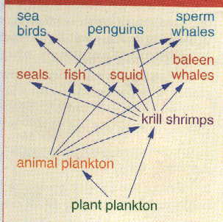  What do the arrows represent in the food chain?
154 | A farmer uses an selective pesticide to combat  the effect that snails have upon his lettuce .  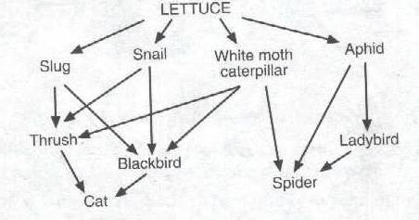  What impact would a decline in the snail popultation have upon the food web? Discuss the effect it would have on at least 5 different species of the population.
155 | Write down the meanings of the following words: producer, consumer, decomposer.
156 | Why are decomposers important?
157 | What does the arrow indicate in a food chain?
158 | Define the term ‘adaptations’.
159 | Briefly explain how Carbon is recycled by decomposers.
160 | Describe what the term ‘behavioural adaptations’ means and give 10 examples.
161 | Describe what the term ‘structural adaptations’ means and give 10 examples.
162 | Describe what the term ‘physiological adaptations’ means and give 10 examples.
163 | Explain why adaptations are important to organisms.
164 | Many years ago there were giraffes with short necks, medium necks and long necks. Discuss why only long necked giraffes exist now.
165 | Distinguish between a food chain and a food web.
166 | Explain the terms Carnivore, Omnivore and Herbivore. Give an example of each.
167 | What are trophic levels?
168 | Define the following terms:  Habitat Species Community Population Ecosystem Ecology Autotrophic Heterotrophic
169 | Explain where the energy in all food webs comes from and how it enters the food web.
170 | Describe the Carbon cycle.
171 | PLANTS  Design an experiment that enables you to answer the following question: “Is sunlight needed for photosynthesis?”
172 | Write down a formula equation that describes the process of photosynthesis.
173 | List three ways that plants are adapted to receive the maximum amount of sunlight.
174 | You are asked to help your friend perform a starch test on a leaf. Produce an instruction sheet that she can use.
175 | Write down a word equation that describes the process of photosynthesis.
176 | Label the diagram and provide the  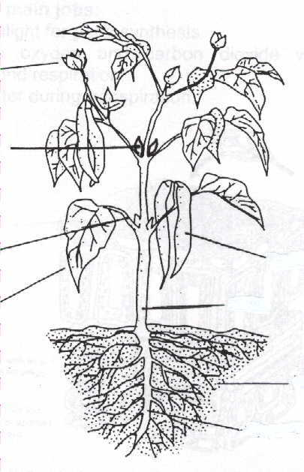  function(s) for each part of the plant.
177 | Why do animals generally eat the roots, seeds or fruits of plants in preference to the leaves?
178 | Tussock grass grows in areas that are very exposed to wind and sunlight.  The American Cactus has adapted for survival in arid conditions.  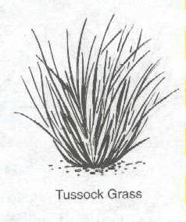  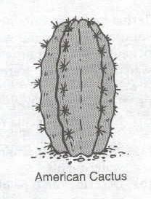  Discuss the plant adaptations in each instance.
179 | Explain what is meant by the term “Transpiration”.
180 | Photosynthesis requires ………………. ……………………. ………………………. and ……………….
181 | Photosynthesis is the conversion of ……………………………………….. into ………………………………..
182 | Draw a cross section of a leaf and label the different structures.
183 | For the structures you labelled in Question 182, write down how they help the plant survive.
184 | Decide, with reasons, which environment, A, B or C, each of the plants in the diagram would live in.  - High in dense bush canopy.  - On the floor of the bush.  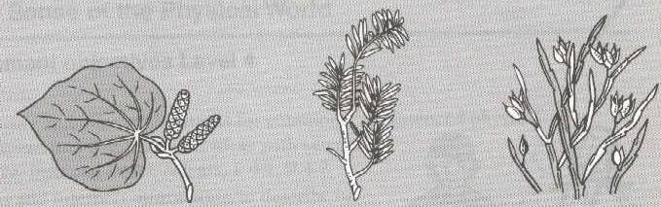  - On an exposed mountain
185 | Identify where in a plant the following processes occur.  Photosynthesis, absorption of water, reproduction, absorption of minerals, transportation of water, transpiration, transportation of sugars.
186 | Explain the importance of photosynthesis.
187 | Name the raw materials of photosynthesis.
188 | Name the products of photosynthesis.
189 | Draw a plant and label the structure.
190 | Explain the function of the structures in Question 189.
191 | Draw a flower and label all parts.
192 | Name the male reproductive parts of a flower.
193 | Name the female reproductive parts of a flower.
194 | Define the terms ‘pollination’ and ‘pollinators’ and explain the difference.
195 | Explain the importance of pollination.
196 | Explain the process of fertilization in plants step by step.
197 | List the different ways plants can be pollinated.
198 | Describe the term ‘seed dispersal’ and explain its importance.
199 | List the different ways seeds can be dispersed.
200 | Distinguish between the phloem and the xylem. Make sure you describe the function of each in your explanation.
201 | Name the major area for food storage in plants.
202 | Name the substance that glucose is stored as in plants.
203 | Name the site of photosynthesis.
204 | Draw the structure of a seed and label the parts.
205 | Describe the function of each structure labelled in Question 204.
206 | Define the term ‘germination’.
207 | Describe the requirements needed for a seed to germinate.
208 | Distinguish between sexual reproduction and asexual reproduction.
209 | List the advantages of sexual reproduction.
210 | Discuss the importance of photosynthesis in the survival of all species.
Below is a chart to list the topics/headings/parts of Science to sort the stuff you find easy from the things you find quite difficult. List it all down and spend time on the stuff you struggle with. Make sure you ask me for help!!!
The parts of Science I am good at | The parts of Science I am ok at | The parts of Science I struggle with
Extra notes to add/Reminders etc:
Miss Allen’s tips for exams
Before the exam:
Drink lots of water and eat healthy foods so that your brain is able to think clearly.
Go over notes and questions on a regular basis.
Start your study as early as possible, to allow your brain more time to transfer the information into your memory.
Don’t try and cram in information at the last minute. This can cause the brain to panic and forget information.
It is never too late to ask for help. If you are struggling with something, ask me (or someone) for help.
Have a healthy breakfast the morning of the exam – eat even if you are nervous!!!
Get a good nights sleep in the few nights leading up to the exam – you don’t want to be tired!
In the exam:
My number one tip for exams is never leave anything blank. Answer every question. You can’t get any marks if you don’t write anything, but there is a possibility you will get some marks even if you have no idea what you are talking about – so give it a go!
Sometimes when we come across a question you immediately give up on it because it looks too hard. Remember that they are only asking you things that you have been taught, so if you get stuck, remember that it must be something that you have learnt this year. Look for key words in the question, highlight them and focus your answer around those words. If you really can’t do it, move on to the next question and come back to it at the end.
Look for key words in questions so you know what they are asking you what to do. The words often used and what they want you to do when they use those words are listed below:
Define… and Describe…: They want to know what it is
Purpose: They want to know the reason that it happens
Explain why…: They want to know what it is and why it happens (reason/purpose)
Explain how…: They want to know what it is and how it happens (process)
Discuss/Evaluate/Justify…: They want you to use higher level thinking explain and link together concepts to describe something. A good way to make sure you have covered all points is by thinking of the 4Ws and 1H
What? Why? When? Where? How?
Remember to keep calm, panicking causes you to forget.
GOODLUCK FOR YOUR EXAMS!!!
From Miss Allen

